Oil, Gas & Mineral Law
Outline, PT I
by corbin b.p. dodge
More outlines available at www.corbin-dodge.com
Spring 2013
Professor Jones
South Texas College of Law
Basic Concepts 3
Definitions 3
Ownership of Minerals 3
Rule of Capture 3
Enhanced Recovery Operations 4
Oil & Gas Lease as a Conveyance 5
Nature of the OGL 5
Interests Created by OGL 5
Surface Use 6
Accommodation Doctrine 6
Clauses Affecting Lease Duration (Savings Clauses) 7
Habendum Clause (Term Clause) 7
The Primary Term (PT) 7
Delay Rental Clause (“Unless” Clause) 7
The Secondary Term 9
Savings Clauses in The Secondary Term 9
3 Contingencies of the Operations Clause 10
A. Cessation of Production Clause (30-60 Day Clause) 10
B. Continuous Operations Clause 10
C. Dry Hole Clause 10
Shut in Gas Royalty Clause 10
Force Majeure Clause 12
Conservation of O&G 13
Purposes of Conservation 13
Role of the TX RRC 13
CT Review 13
Statewide Spacing & Density Rules 13
Duty to Plug Wells 13
K Provisions of an OGL 14
Express Covenants 14
Market Value at the Well Clause 14
Take or Pay Provisions 14
Division Order Title Opinion (Executory Accord) !!! 15
Implied Covenants 16
Duty to Protect 17
Duty to Develop (Implied Covenant of Reasonable Development) 17
Duty to Manage & Administer 17
No Duty to Restore 17
No Duty to Notify Lessor of COAs 17
No Duty to Explore 18
Remedies for breaches of an implied covenant 18
Special OGL Clauses 19
Cut-Down Clause (Proportionate Reduction Clause) 19
Mother Hubbard Clause (Cover-All Clause) 19
Property Concepts 20
Minerals & Other Minerals 20
Nature of Ownership 20
Acquisition of Title 20
Separation of Minerals from Surface 21
Loss of Title 21
Abandonment 21
Adverse Possession 21
Dormant Mineral Interests Acts 21
Leases from Unlocatable or Contingent O’s 21
Partial Estates (Divided Ownership) 22
Co-tenants (Tenancy in Common) 23
Types of Co-tenants 23
Successive Ownership: Life Estates & Remaindermen 23
Terminable Interests 24
Trespass 24
Geophysical Trespass 24
Physical Trespass 25
Slander of Title 25
Mineral & Royalty Interests 26
Attributes of the Severed Mineral Estate 26
The Executive Right 26
Power of the Executive (Mineral O’s) 26
Duties of the Executive 26
Rules of Construction 26
The 4 Corners Rule 26
Estoppel by Deed: “Duhig Rule” 27
EXCEPTION to Duhig #1: Formally Express Intent 27
EXCEPTION to Duhig #2: Double Grant Rule & The Subject to Clause 27
EXCEPTION to Duhig #3: Land Described vs. Land Conveyed 27
“In and Under” 27
Special Problems 28
Non-Apportionment Rule 28
Entirety Clause 28
Rule Against Perpetuities 28
Business Transactions by Lessee 29
Lease Assignments 29
Farm-outs 29
Joint Operating Agreement (JOA) 29
Drilling K’s 30
White Oil (Hydrocarbon Liquids) 30
Pooling & Unitization 31
Voluntary Pooling 31
The Lease Pooling Power 32
Community Lease 32
Pugh Clause (protects lessor) 33
Anti-Dilution Clause (protects lessor) 33
Compulsory Pooling 33
Effect of Pooling 34
Field-wide Utilization 34
Special Problems 35
Ownership of Streambeds/Navigable Streams 35
Strips and Gores 35
Accretion/ Reliction 35
Bar Exam Illustrations 36
Question 9 In 1994… 36
Question… Alex owned 36
Question…. 36
Practice Problems 36
Bar question, Greg owned… 36
Green/Blue Practice Problem 36
Test tips 37
Basic Concepts

Definitions
- Shale: Source rock (not reservoir rock)
- Fracturing: Allows production out of source rock
- Porosity: Pore spaces in rock
- Permeability: Ability to move bw pore spaces
- Rock Matrix: Surface O owns it. Mineral O only owns the contents.
- Native Gas: Naturally there
- Peaking Facilities: Stores gas for peak demand times & emergencies
- Commingling: Calculating amount of stored gas vs. native gas in a storage reservoir
- Gas Chromatographic Test: Finds the chemical traits of NG
Figure 1: Plan View
Figure 2: Cross-Sectional View

Ownership of Minerals
- Majority (TX) Ownership in Place: Landowner owns OG beneath his land, qualified by ROC (lose ownership if it migrates)
- Minority (CA, OK, LA) Non-Ownership Theory: Landowner doesn’t own OG underneath. Only has exclusive right to capture
- CL ad coleum: Landowner owns everything above & beneath his land (to center of the Earth) Del Monte v. Last Chance, 1

- Fractionalization: Division of property interests EX: Surface rights, Mineral Rights
- Horizontal Severance: Fee O has right to convey minerals beneath his land, but retain title to the surface

Rule of Capture

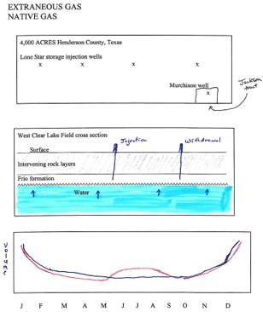
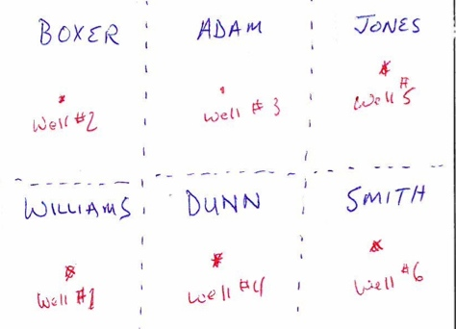
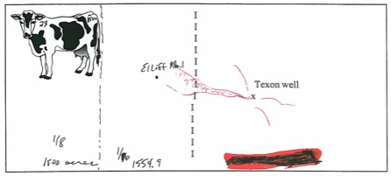
p007 Lone Star,
HORCO v. West
P015 Ownership in Place & Rule of Capture
p015 Eliff v TX Drilling

- Historical: Gas was farae naturae. Once you return gas it was no longer personal property Hammonds v. Central KY, 2
- Modern Rule: No liability for draining OG beneath a neighbors land
- Effect: Gives a mineral rights owner title to OG produced from a lawful well, even if it flows from another’s tract.
- Nutshell: You don’t own OG under your land (not specific). You own the fair chance to extract it
- Purpose: Limits ownership before extraction. Oil changes title when it migrates across property lines
- Remedy: Correlative Rights Doctrine: OG O has right to produce a fair share of OG in a common reservoir
- Doesn’t Apply: Once OG produced (becomes personal property)

- Problem: Rule of Capture | Answer
What remedy does A have if a neighbor’s well is draining OG on her property? | Under the correlative rights doctrine, an OG O has the right to produce his fair share of OG from a common reservoir. Thus, A can got & do likewise; she can drill a well on her property to produce her fair share of OG from that common reservoir.
Can A receive a share of the OG that her neighbor has already produced? | No. Once OG is produced it becomes personal property. The neighbor is not liable to A for the title they obtained to OG from a lawful well, even if it flowed from a neighbors (A’s) tract.

Limits on the Rule of Capture
- Trespass EX: Slant drilling
- Nuisance
- Negligence Eliff v. Texon Drilling, 15
- Violating rules of a conservation agency EX: Illegal production
- Interfering w/ a neighbors correlative rights

Enhanced Recovery Operations
- Reinjection of Natural Gas (Extraneous Gas)
  - Definition: Gas re-injected into a storage reservoir after extraction
  - Majority (TX): OG are mineral realty when undisturbed. Title to extraneous gas is preserved upon reinjection (personal property of injector bc already severed), unless abandoned
    - Gas, once severed, becomes personal property & isn’t subject to ROC Lone Star Gas v. Murchison, 4
  - Comingling
    - Definition: Extraneous gas comingled w/ untouched gas Can meet > Owe royalties on %
    - Rule: Comingler’s BOP to show the % Can’t meet > Owe royalties on 100%

- Fracing Coastal Oil v. Garza Energy, 19
  - Definition: Use of explosives or vibrations to increase rock permeability
  - Rule: ROC bars DAS for subsurface hydraulic fracturing of natural gas that extends under another’s property. Not trespass.
    - Subject to the ROC. Not responsible to adjoining property owners if it’s a lawful well
  - Effect: Your property > Can act at will unless nuisance or trespass
  - Allowed: Can frace your own land (easier to drain neighbor)
  - Not Allowed: Can’t frace neighbors land bc trespass. Not actionable bc ROC (can’t sue for minerals)

- Waterflooding People’s Gas v. Tyner, 12
  - Allowed: No trespass
  - Not allowed: Trespass. Liable for lost profits
  - Secondary recovery
  - Tertiary recovery: heat, gas

- Waste
  - Common pool > Can drain but can’t waste it or injure common property
  - Rightful land possession > Can waste aka private waste

Oil & Gas Lease as a Conveyance

Nature of the OGL
- Definition: Conveyance of a determinable fee in the mineral estate under which the mineral O (usually landowner) conveys to the lessee (usually OilCo) the right to explore for and produce OG under the mineral O’s property. Lessee receives a FSD to that OG. Lessor retains right to use the surface & the possibility of reverter when the lease ends. !!! Concord Oil v. Pennzoil, 30
- General: A conveyance & K. Not a lease. Not a landlord-tenant lease. Cherokee Water v. Forderhause, 27
- Purpose: Governs relationship bw lessors & lessees in exploration & production
- Fee Simple Determinable (FSD)
  - Look for: “for 10 years, plus so long as production continues”
  - Duration: Can last forever, but has the possibility of reverter when the fee determines (ends when conditions met)
  - Can abandon, convey, or inherit
- Producers ADA: Designed to benefit oil company
- Legal Description: § of Frauds: In writing & signed by the party to be charged…
  - Notarize & record at counties Official Public Records
  - Purpose: TX is a Race Notice Jsd - party who files lease first gets the ball
- Primary term: Usually 3 yrs (used to be 10)

- Problem: OGL Conveyance | Answer
Lessor owns all the mineral estate (8/8) and executes an OGL to convey the mineral estate.  What has the lessor conveyed and what does the lessor retain? | The lessor conveyed all the mineral estate (8/8) in FSD but retained a possibility of reverter. The lessor also receives all rights that are bargained for in connection with the lease, which usually include the payment of royalties, delay rentals, and bonuses.
What else does the lessor receive? | The lessor also receives all rights that are bargained for in connection with the lease, which usually include the payment of royalties, delay rentals, and bonuses.

Interests Created by OGL

LESSOR = SERVIENT ‘SURFACE’ ESTATE = SURFACE ESTATE OWNER = ROYALTY INTEREST

LESSEE = DOMINANT ‘MINERAL’ ESTATE = MINERAL RIGHTS OWNER = WORKING INTEREST
ORI Comes out of the Working Interest (the leasehold interest)
this is the OGL lease estate

- Working Interest
  - LESSEE’S INTEREST (OilCo that has the mineral lease)
  - Effect: Lessor receives all interests, except those reserved for lessee in OGL
  - Aka: Operating interest, leasehold interest
  - Mineral Estate Owner’s Rights “Bundle of Sticks” (TX)
    - Right to explore for & produce, right of ingress & egress
    - Executive Right: Right to execute documents w/ respect to mineral estate EX: When you sign OGL
    - Right to Bonus: Consideration for executing OGL EX: Down payment
    - Right to Delay Rentals: Consideration for delaying operations &/or production
    - Right to Royalty: Payments based on a fraction or % of production proceeds, free of the cost of drilling, completing & equipping the well (incorporeal interest)
    - Right of Reverter: Rights terminate when the lease term ends & rights revert to grantor (when fee determines)
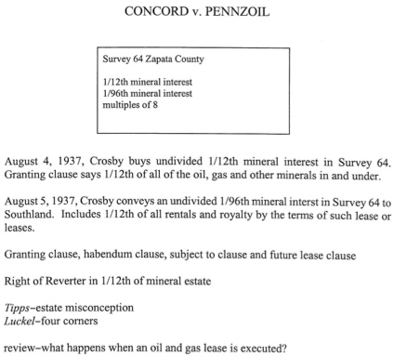
p030 Concord v. Pennzoil
- Royalty Interest
  - LESSOR’S INTEREST (Landowner who signs OGL)
  - Receives down payment, bonus, & royalties
  - Definition: Share of production w/out production costs
  - Effect: Non-possessory interest w/ no operating rights
  - Surface Owner’s Rights: Right to use & enjoy the surface except for surface rights that belong to mineral O

  - 3 Types !!!
    - Lease Royalty Interest (LRI): Lessor’s interest in production under the OGL
    - Overriding Royalty Interest (ORI)
      - Arises from working interest, usually for geologist-developer & land man
      - What lessee gets when they sign an OGL
      - Washout: Can be washed out if lessee signs new lease bc old lease terminates (life of ORI is co-terminus w/ life of OGL) !!!

    - Nonparticipating Royalty Interest (NPRI) !!!
      - Conveyed or reserve by a present or former mineral/property O
      - No right to royalties
      - Duration: Perpetual or limited in time. Doesn’t end when lease ends
      - Term NPRI: Limited by a term of years EX: “15 year NPRI”

  - Similarities bw the 3 types
    - Uncertain forms of compensation
    - Not req’d to pay any exploration or production costs
    - Non-possessory. No operating rights. No right to develop or lease
    - Non-executive interests

Surface Use
- Rule of Reasonable Necessity
  - Rule: Once the mineral estate is severed from the surface estate, the mineral estate can use so much of the surface estate as is reasonably necessary to carry out the purposes of the mineral grant !!!
  - Purpose: Impliedly authorized to produce & remove minerals bc it’s the dominant estate

- Includes
  - Use of sand, gravel & caliche, crushed limestone for drill site
  - Use of surface for seismic surveys
  - Use of fresh water or salt water Water always part of the surface
  - Disposal of salt water
  - Construction of roads, tank batteries, compressor sites, meter runs & separation facilities
  - Selection of location drill sites
  - Timing of drilling operations
  - Damage to standing timber, improvements, moveable personal property EX: Must cut trees down to drill
  - Right to draw casing & remove equipment
  - Right to add or remove electric/telephone lines
  - No duty to restore premises unless expressly obligated !!!

- Exceptions !!!
  - Accommodation Doctrine: Mineral O & his lessee must accommodate surface uses where reasonable alt’s are available
  - Negligence
  - §’s, Ordinances, Lease Terms

Accommodation Doctrine
- Definition: Mineral O must accommodate the surface O if mineral O’s proposed surface use will substantially impair existing surface uses & he has reasonable alternatives available Getty Oil v. Jones, 31

- Getty Requirements On Exam !!!
  - 1) Existing surface use &
  - 2) OG development precludes that use &
  - 3) Reasonable alternative exists &
  - 4) It’s available on the lease premises Sun Oil v. Whitacre, 34
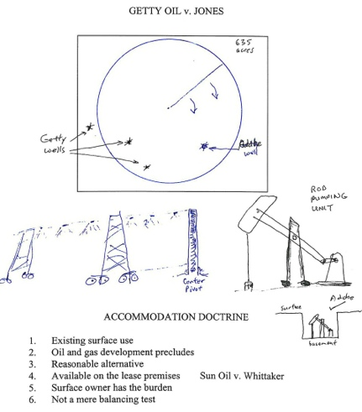
- Standard of Liability for Surface Damage: Negligence
- BOP: Surface O must prove all 4 elements (not a balancing test)

- What do you have to accommodate? On Exam !!!
  - Existing Surface Use: Pivot irrigation system GenCo v. Valence Petroleum
  - Not Existing Surface Use: Grazing cattle or growing crops
  - Repudiation by lessor
    - If OG Relies on Repudiation
      - Effect: OG’s obligations are suspended while in Ct (estoppel)
      - Applies: Landowner puts sign up that lease expired & files Cheyenne Resources v. Criswell, 38
      - Policy: Lessors repudiation is a direct attack on lessees title
    - If OG disregards repudiation & continues to produce: Must pay 100% of production

- Limits
  - Must exercise due regard to for surface O’s rights
  - Beyond reasonable necessity → Trespass. Not a balancing test.
  - To limit lessee’s actions → Surface O’s BOP to show the lessee’s actions aren’t reasonably necessary (high)
  - EX: In TX 5 acres is generally needed to drill a well

Clauses Affecting Lease Duration (Savings Clauses)
- Purpose: Maintains FSD to keep OGL alive
- Types
  - Habendum Clause (& alternative HC)
  - Cessation of Production Clause
  - Delay Rental Clause

Habendum Clause (Term Clause)
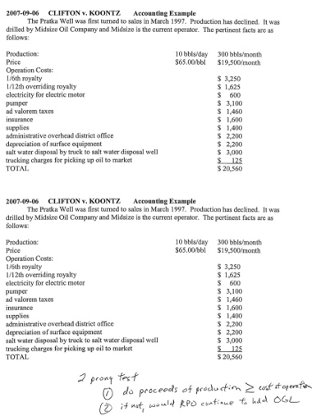
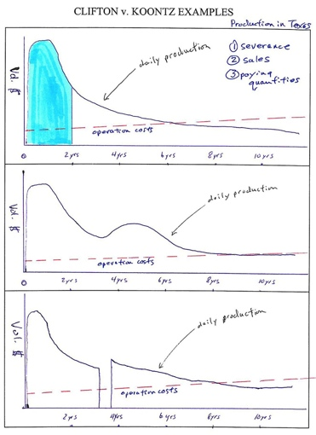
p044 Clifton v. Koontz

- Example: “…lease shall be for a term of 3 years from this date (called the “primary term”), & as long thereafter as oil, gas, or other mineral is produced…” or “… as long as the well shall produce in paying quantities”
- Look for:“to have & to hold”
- Definition: Fixes ultimate lease duration. Req’d to hold the lease long-term Cheyenne Resources v. Criswell, 38
- Qualifications
  - Can continue lease for something other than production w/ a savings clause
  - Can terminate lease early w/ drilling & delay rental clause
- Measured by: A term of years + so long as the well is produces

Alternative Habendum Clause
- ¶2 of our OGL: Unless sooner terminated or longer kept in force under other provisions hereof, this lease shall remain in force for a term of 3 years from the date hereof, hereinafter called "primary term", and as long thereafter as operations, as hereinafter defined, are conducted upon said land with no cessation for more than 90 consecutive days.

- Operations defined in ¶6: 'operations' shall mean operations for and any of the following: drilling, testing, completing, reworking, recompleting, deepening, plugging back or repairing of a well in search for or in an endeavor to obtain production of oil, gas sulphur or other minerals, excavating a mine, production of oil, gas, sulphur or other mineral, whether or not in paying quantities.

- Purpose: Changes “so long as production” to “so long as operations” See Figures, pg 14
- Effect: Greatly expanded. Great for OG lessee
- Operations: Must be more than painting the tank

The Primary Term (PT)
- Net effect of Habendum Clause + Drilling and Delay Rental Clauses is to create timeline that divides OGL into 2 segments

- Duration: Fixed # of years as stated in OGL
  - Lessee has option to drill
  - However under the drilling & delay rental clause, they must either commence drilling or pay delay rentals (on or before the anniversary date) to hold the lease
- Related Clause: Drilling & Delay Rental Clause
- Key Issues
  - Was OGL held by payment of delay rentals?
      - Was OGL held by the commencement of operations for drilling (by end of PT)?

Delay Rental Clause (“Unless” Clause)

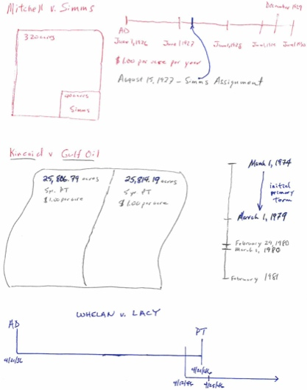
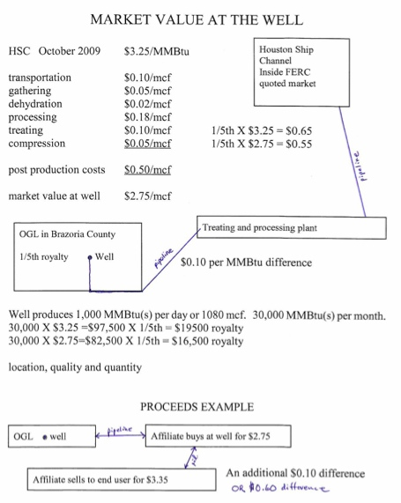
p068 & p070 Mitchell, Kincaid and Whelan
p157 Market Value at the Well

- Look for: “If operations for drilling are not commenced… on or before one year from this date, the lease shall terminate as to both parties, UNLESS on or before such anniversary date Lessee shall pay or tender (or shall make a bona fide attempt to pay or tender to Lessor… the sum of $___ / PER ACRE.. which shall cover the privilege of the deferring commencement of drilling operations for a period of twelve (12) months. In like manner and upon like payments… the commencement of drilling operations may be further deferred for successive periods of twelve (12) months each during the PT…”
- Definition: Special limitation on FSD that must be paid annually to the right person, at the right time, and the right place
- Effect if Satisfied: Delay rental payment acts as a substitute for production that allows the lease to extend past the anniversary date
- Effect if Not Satisfied: Lease terminates
- Applies: Only during PT if hasn’t commenced drilling
- Doesn’t Apply: If commenced operations for drilling during the PT → Extends lease into the secondary term
- Cost: per acre EX: 1200 acres = $1200 DR payment
- Benefit: A trap to extend the lease that allows time to evaluate the prospect EX: Wait for results of neighbors well
- To Convey Delay Rental: Must meet §oF

- Rules of Construction
  - “Unless” Clause: Imposes a condition. Automatic termination.
  - “Or” Clause: Imposes an affirmative duty. Requires a forfeiture clause to terminate. (Rare in TX)
  - “Paid Up Lease”: Single payment at the time of execution which maintains lease for short PT
    - Look for: “This is a paid-up OGL; no delay rental payments are req’d during the original 3 year term.”or
    - This is a paid-up OGL; In consideration of the good and valuable consideration paid to Lessor by Lessee… Lessor agrees that Lessee shall not be obligated to commence or continue any operations w/in the PT of this lease...

- Exceptions
  - Equitable Estoppel Humble Oil v. Harrison, 64
    - Lessor can’t claim lease terminated if they accept a late delay rental payment
    - Ambiguous ownership, caused by lessor

  - Bona Fide Attempt Provision Kincaid v. Gulf Oil
    - Look for: “OR shall make a bona fide attempt to pay or tender to Lessor”
    - Rule: Ct very strict about paying the right person, at the right time unless a bona fide attempt provision is in the lease
    - Effect: Lessor makes a bf attempt to pay → Protects OG co
    - Advantage: strengthens OGL
    - Applies: Bank or Post Office errors (if lease says can pay by mail). Clerk forgot to pay on time, etc

  - Commencement of Operations for Drilling
    - Applies: Substantial performance (some activity related or preparatory to drilling if good faith & diligently pursued)

- EX: How an OGL w/ delay rental clause extends the lease | Answer
An OGL provided for a 3 year PT starting on 2/3/2012. w/ an anniversary date of 2/4/2015. The PT commenced but there was no production. What is the anniversary date? | The anniversary date is 2/4/2015.  2/4/2012 → 2/4/2013 → 2/4/2014 → 2/4/2015
When are delay rental payments due? | Delay rentals are due on 2/4/2013, then 2/4/2014, then 2/4/2015.
What result if they failed to pay a delay rental on 2/4/2015? | An OGL usually requires production by the end of the PT. Assuming there was no production, and that the lease allowed for payments of delay rentals, failure to pay delay rentals during the PT would result in termination of the OGL.

The Secondary Term
- Created by: “thereafter” clause
- Look for / Duration: “as long thereafter as OG is produced”
- Related Clauses: Production or Savings Clause
- Key Issues
  - Is there production & what does production mean?
    - TX: Produce & Market. Production must be in paying quantities
  - What constitutes “in paying quantities”?
    - 2-Prong test: S < Cost of operation & RPO
    - Lessor must win both prongs
  - What are the “savings clauses” & has one of them been satisfied?
    - Operations, Force Majeure, Shut-in Royalty operate as substitutes for production
- Requirement: Production in paying quantities
- Produced: In paying quantities Garcia v. King, 41
  - “Produced” Requirements !!! Anadarko Pet. v Thompson, 53
    - Severence (occurs at wellhead) &
    - Sales
    - In paying quantities

  - Doesn’t Apply: Mere discovery

- In Paying Quantities !!! Clifton v. Koontz, 44
  - Definition: Even a small profit over operating expenses…
  - Applies: …Even if it will never pay costs & production as a whole is unprofitable
  - 2 Prong Test !!!
    - Do operating revenues exceed operating costs?
      - $ > cost of operation → Lease valid, even if never recovered drilling, equipping & completing expenses
      - BOP: Lessor
    - Even if $ < Cost of operation … would a RPO hold the lease w/ expectation of profit & not for speculation?
      - EX: Lessor holds on to well w/ Eagle Ford shale under it, expecting Conoco will buy for $5K/acre w/ ¼ royalty

  - Timeframe: w/in 1 year
  - Operating Costs: Labor, Utilities & pumping costs, Minor repairs, Severance taxes, production equipment depreciation (but not drilling equipment)

  - Don’t consider these costs
    - 1. Drilling
    - 2. Completing
    - 3. Equipping
  - Notes
    - NRI = 75% | RI = 25% ORI comes out of NRI
    - EX: Working interest O pays 100% of expenses, but gets >100% of the $
      - So don’t count the ORI against lessee operator Don’t subtract overriding royalty !!!
    - Capital Expenses: Don’t include capital expenses in the profit formula Pshigoda v. Texaco, 47

- See page 13 of 29th Lease Perpetuation Annual Advance, O, G & Energy.ppt Stanolind O&G v. Barnhill, 50
  - If, w/in 5 yrs from the anniversary date, appellants have developed and produced oil or gas from said land in paying quantities >> their interest in the estate continues…otherwise OGL terminates & lessor can’t prevent it.
    - ADD PIC FROM PG 32 SUPPLEMENT

Savings Clauses in The Secondary Term
- Purpose: Act as substitutes for production to hold the lease (modifies the Habendum Clause)
- Requirements: Diligently try to find a market & reasonable probability of sale
- General: In most modern leases. Require lessee to begin attempting to restore production w/in the express timeframe
- Types of Savings Clauses
  - Shut-in Royalty Clause
  - Dry hole, operations & cessation of production clause
  - Force Majeure Clause
  - Pooling Clause* *Savings feature incidental to its main function

3 Contingencies of the Operations Clause
- What they have in common: Typically interwoven into a single clause to keep lease alive w/ operations

A. Cessation of Production Clause (30-60 Day Clause)
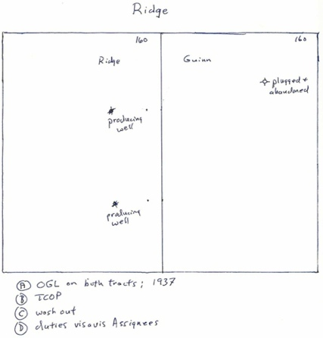
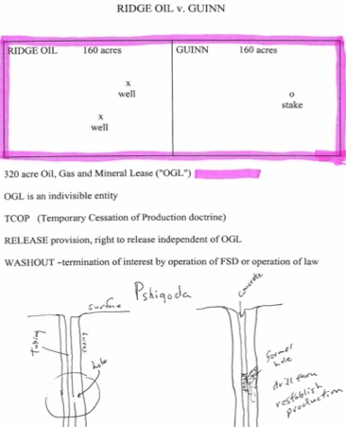
p057 Ridge v. Guinn

Main Rule: To hold a lease during the secondary term, lessee needs production or satisfy a savings clause
Look for: “if production should cease…lessee has 30/60 days to commence add’l drilling or reworking operations.”
- Rule: Overrides the CL temporary cessation of production doctrine Samano v. Sun Oil, 82
- Requirement: Must work diligently & eventually restore production (but not w/in that 60 days)
- Exception: Unless states “capable of production”

- Temporary Cessation of Production (TCOP) Ridge Oil v. Guinn, 57
  - Rule: A TCOP doesn’t terminate OGL. Allow reasonable time to repair
  - Reasonableness Factors
    - Length of shutdown
    - Cause
    - Attempts to restore production
    - Foreseeability & unavoidable aren’t essential factors !!!
  - Policy: Mechanical things break down. An implied excuse, not written in lease
  - Historical (CL): OGL didn’t terminate unless the cessation was permanent → TCOP arose

B. Continuous Operations Clause
- Look for: In Habendum Clause“Unless sooner terminated or longer kept in force under other provisions hereof, this lease shall remain in force for a term of 3 years from the date hereof, hereinafter called “PT”, and as long thereafter as operations, as hereinafter defined, are conducted upon said land with no cessation for more than 90 {or 60} consecutive days. & several paragraphs later: ….'operations' shall mean operations for and any of the following: drilling, testing, completing, reworking, recompleting, deepening, plugging back or repairing of a well in search for or in an endeavor to obtain production of oil, gas sulphur or other minerals, excavating a mine, production of oil, gas, sulphur or other mineral, whether or not in paying quantities.

- Definition: Provides the lease won’t expire while lessee is engaged in drilling or reworking operations
- Requirement: Physical operations for drilling or reworking & pursued in good faith & reasonable diligence
- Applies: When at the end of the PT, operations commenced & continuing but no actual production yet

C. Dry Hole Clause
- Look for: “...If at the expiration of the PT, oil, gas or other mineral is not being produced on said land, or on acreage pooled therewith, but Lessee is then engaged in drilling or reworking operations thereon or shall have completed a dry hole thereon with 60 {or 90} prior to the end of the primary term, the lease shall remain in force so long as operations on said well or for drilling or reworking of any additional well are prosecuted with no cessation of more than sixty (60) consecutive days [or ninety (90) days], and if they result in the production of oil, gas or other mineral, so long thereafter as oil, gas or other mineral is produced from said land or acreage pooled therewith...”
- Definition: If lessee drills a dry hole, he can keep the lease alive by drilling another well w/in the timeframe
- Duration: 60 or 90 days
- Applies: Gets valuable info from dry hole EX: Move 500 ft to the west

Shut in Gas Royalty Clause
If lessee drills a well on land covered by this lease... which well is capable of producing gas, but such well is not being produced and this lease is not being maintained otherwise… this lease shall not terminate provided lessee pays or tenders as royalty to the parties who at the time would be entitled to receive royalty hereunder...the sum of money equal to ¼ of the delay rental paid quarterly while this lease is not otherwise maintained. The first payment… shall be made on or before the first day of the calendar month after expiration of 90 days from the date the lease is not otherwise maintained and thereafter on or before the 1st day of each 3rd calendar month during which period this lease is not otherwise maintained.

- Definition: Shut in royalties can be a substitute for production for holding title to the lease, or, if written differently, a covenant
- Shut-in: Capable of production but unable to get to market EX: Can’t store gas if no pipeline
- Applies: Gas
- How it’s used: Provides for periodic payments of a set sum (often same amount as delay rental)
- Duration: Temporary. Lessee can’t hold a lease forever by paying them
- Requirements: Diligently try to find a market & reasonable probability of sale XTO v. Blackmon
- Who gets the Shut-In Royalty? Royalty recipient (not necessarily delay rental payments recipient)

- Rule: Payment of a shut in gas royalty is a condition of the FSD that acts as a substitute for production to keep the lease alive. Payment is all that matters (reason for shut-in irrelevant) Freeman v. Magnolia Pet, 86

- Look for: “If there is a gas well which is shut in, lessee may pay / shall pay or tender to lessor the amount of the delay rental . . . and if so it will be deemed that such well is producing oil or gas in paying quantities.”
  - “May Pay” → It’s a Substitute for Production MORE SERIOUS
    - Lease terminates if condition not met (it holds the lease)

  - “Shall Pay” → It’s a Covenant LESS SERIOUS
    - A mere promise so lessee shall pay by holding lessee to a K obligation (i.e. a well capable of production holds the lease)
    - Right to sue but doesn’t terminate OGL

- When are Shut-In Royalties due?
  - During primary term → Must pay before end of PT
  - During secondary term → Communicate w/ drillers so you can make payment asap
  - Leases were altered to say that payment may be made either 60 or 90 days after the well was shut-in
  - If OGL says “annually thereafter” → Pay exactly one year later
  - Grace periods expressly upheld

Problem like this on Exam !!! | Answer
An OGL provided for a 3 year PT w/ an anniversary date of 2/15/2008. The lease covered a 640 acre tract and stipulated that delay rentals were $10 per acre due every 3rd month thereafter. The well was drilled across the end of the PT, but was later shut-in on 2/24/2011, w/ production turning to sales on 10/6/2011.  Lessor A: Undivided 50%  Lessor B: 12.5%  Lessor C: 12.5%  Lessor D: 25%  When are shut-in gas royalty payments due? How much? | 2/24/2011 to 2/28/2011 5 days  3/1/2011 to 3/31/2011 31 days  4/1/2011 to 4/30/2011 30 days  5/1/2011 to 5/24/2011 24 days  Total = 90 days  The 1st payment is due on 6/1/2011. The 2nd payment is due on 9/1/2011 bc “every 3rd month thereafter.”  The delay rental payments are $10/acre for 640 acres, totaling $6400. The payments are as follows:  ¼ of $6400 = $1600  A gets ½ of $6400 = $3200  B gets ___ of $6400 = $____  C gets ___ of $6400 = $____  D gets ¼ of $6400 = $1600
Are shut in gas royalties due on 12/1/2011? How much? | Yes, it must be paid by 12/1/2011 to cover back to 9/1/2011.  2/24 → 6/01 → 9/01 → 12/1  The well turned to sales on October 6, 2011

- Another form (every 30 days)
- While there is a gas well on the Leased Premises or on acreage pooled therewith, capable of producing gas in commercial quantities, but gas is not being sold or used therefrom, LESSEE shall pay LESSOR a shut-in gas well royalty…shall be $5.00 per acre, per month, during any such time that LESSEE is obligated to pay.... The first payment shall be due and payable on or before 60 days after shut-in and subsequent payments shall be made every 30 days thereafter for each 30 day period thereafter as long as it’s shut-in. LESSEE shall not be permitted to recover any shut-in royalties paid from royalties on actual production. After the PT expires, this lease shall not be held solely by payment of shut-in gas royalties for a period longer than 24 cumulative months. (emphasis added).

- If, at the expiration of the PT or at any time or times thereafter, there is any well on said land...capable of producing oil or gas, and all such wells are shut-in, this lease shall, nevertheless, continue in force as though operations were being conducted on said land for so long as said wells are shut-in...Lessee covenants and agrees to use reasonable diligence to produce...or market said minerals ...but...isn’t obligated to install or furnish facilities other than well facilities and ordinary lease facilities of flow lines, separator, and lease tank, and shall not be req’d...to market gas upon terms unacceptable to Lessee. If...all such wells are shut-in for a period of 90 consecutive days...then at or before the expiration of said 90 day period, lessee shall pay... as royalty, $1 for each acre.
- 3 primary qualifications generally imposed on the various ownership interests created by OGL: (1) general and special limitations; (2) conditions subsequent; and (3) covenants...The breach of a condition doesn’t, of itself, divest the estate of the lessee, but to do this the lessor must, by express act, take advantage of the same by re-entry, or that which in law would be equivalent ...A conditional limitation marks the period or event which is to determine the estate without entry or claim, and no affirmative act is necessary to vest the right in the grantor or him who has the next expectant interest.

In case of doubt as to the true construction of a clause in a lease, it should be held to be a covenant, and not a condition or limitation (bc law doesn’t favor forfeiture)

- Examples: Shut-In Gas Royalties | Answer
Could you open the valve and the hiss of gas escape? | No, shut-in gas royalties don’t apply if the well is purposefully shut-indue to an intentional act

Force Majeure Clause
- Purpose: Relieves lessee from liability for breach if an unpreventable force majeure impedes performance
- Requirements
  - Clause must be in lease &
  - Act of force majeure identified in lease &
  - Nexus bw event & non-performance & i.e. Event must prevent performance
  - Must be unexpected, not caused by your actions &
  - Extension Clause
    - Rule: A force majeure clause needs an extension clause to accomplish anything in an OGL
    - Look for: “during the time of a force majeure, lessee or lessor shall be excused when performance is prevented or delayed” and if based on production “while lessee is subject to force majeure the primary term and the secondary term shall be extended until the end of the force majeure and all delay rentals shall be extended 6 months from the end of the force majeure” or
    - “...When drilling, reworking, production or other operations are delayed or interrupted by force majeure, that is, by storm, flood or other acts of God, fire, war, rebellion, insurrection, riot, strikes, differences with workmen, or failure of carriers to transport or furnish facilities for transportation, or as a result of some law, order, rule, regulation, requisition or necessity of government, Federal or State, or as a result of any cause whatsoever beyond the control of the Lessee, the time of such delay or interruption shall not be counted against Lessee...”

- Rule: Can’t argue force majeure when no fm clause in the lease Haby v. Stanolind, 100
  - A 60-day savings clause, w/out more, when no waiver from lessor, terminates when production ceases for 60+ days
- Effect: Excuses performance (or extends time) bc of unforeseeable factors beyond the lessee’s control
- Commonly includes: Acts of God, Weather, Labor shortages, Gov’t interference
- Rules of Construction: Construe strictly against the invoking party
Conservation of O&G

Purposes of Conservation
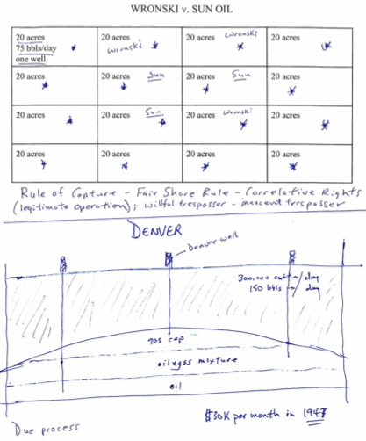
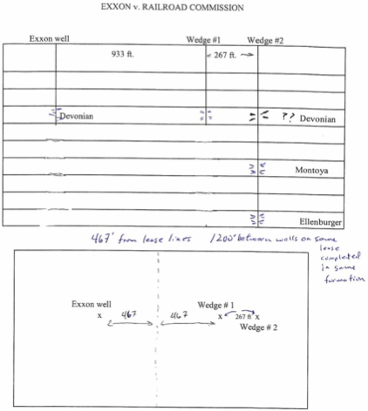
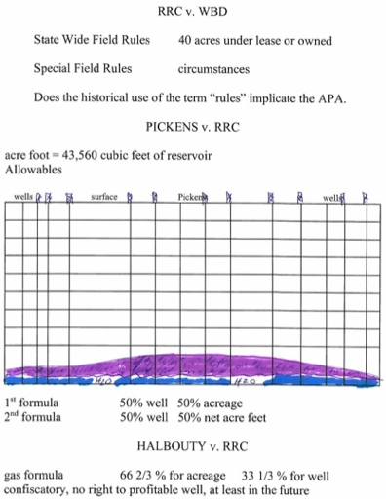
p120 & p124 - Wronski & Denver
p115 Exxon v Railroad
p127 & p134 & p138
WBD, Pickens & Halbouty

- Statewide Rule: 40 acres for a lease, 467’ from lease line, 1200’ from another well on same formation or exception from RRC

Role of the TX RRC
  - X

CT Review
  - X

Statewide Spacing & Density Rules
  - X

Duty to Plug Wells
  - x

K Provisions of an OGL

- Drilling Title Opinion - Lawyer performs to ensure all title owners are included in the lease royalties. If overlooked, you either become their cotenant of a trespasser (both bad for Oil Co)
- Common Royalty Problems (usually oil, not gas)
  - Market Value royalty issues (“Vela” Problem, pg 14)
  - Whether Royalty O’s share in take or Pay Settlements
  - Whether costs are production costs (vs. Subsequent to production)
  - What’s the effect of a division order on royalties
  - Remedy for failure to pay royalties
- OGL establishes a business relationship bw lessor & lessee. Lessee pay lessos royalties as partial consideration for it
- Royalty: a share of the product, free of production costs.
- To increase Royalties: Lessor can increase the value or volume of production (usually w/ implied covenant)

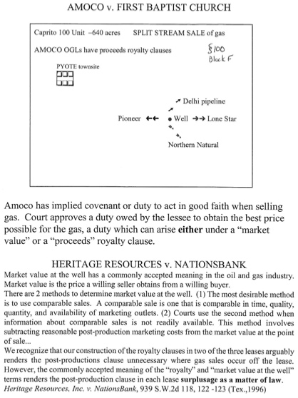
Express Covenants
p157 & p167 - Amoco Pyote Heritage Resources

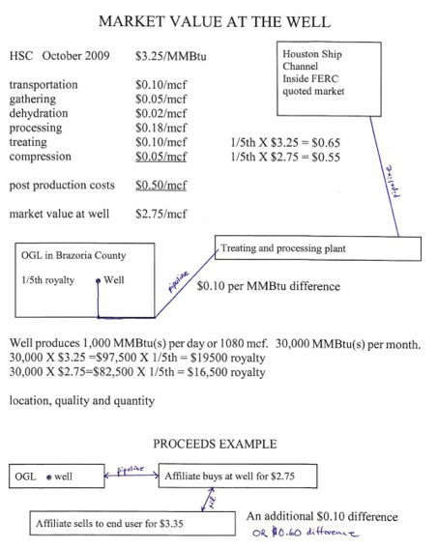
Houston Ship Channel price from FERC, which publishes gas prices

If you sold it at the well, a rational buyer would include all these costs. This is called COST-NETTING to find market value at the well

GROSS PRODUCTION
X PRICE
X ROYALTY FRACTION
= The Amount

Market Value at the Well Clause
- Vela Rule: Royalties on gas made “off the premises” is based on market value (what a buyer would pay a seller @ same time & place of sale) even if sold pursuant to a long-term K at a diff price Yzaguirre
- Equation: GROSS PRODUCTION × PRICE × ROYALTY INTEREST !!!

- 2 Methods to Determine Market Value at the Well
  - Comparable Sales
    - Comparable in time, quality, quantity, & availability of marketing outlets
    - BEST but almost impossible to find so clarify w/ formula in royalty clause for clarification

  - Cost-netting Use when comparable sales isn’t available !!!
    - MARKET VALUE − REASONABLE POST-PRODUCTION MKTG COSTS [@ point of sale] !!!
    - Definition: Subtract reasonable post-production marketing costs from market value at the point of sale
    - Market value at the well lease → Royalty is market value, not long-term K price
    - More favorable to lessee
    - Test: When does production end? That’s when lessor starts covering costs.

- Market Value Royalty Issues !!!
  - Oil → Usually payable in kind @ well-head
  - Gas → Usually lessee will dispose of it & then pay lessor
    - EX: “on gas produced…. & sold…off the premises…. the market value (a fraction of the sale proceeds @ lease premises. Not what lessee gets paid by purchase under their K) at the well of 1/8 the gas sold, provided that on gas sold at the well, the royalty shall be 1/8 of the amount realized (FMV @ time of sale)”

Take or Pay Provisions
- Definition: Long-term gas K can require a party to take a certain amount of gas or pay for a certain quantity at a min. Price [liquidated DAS]
- Look for: “Purchaser shall take __ MCF of gas per year for $__ per MCF or pay for any amount less that that not taken.”
- Purpose: Used to induce or dedicate their reserves to the K
- Usage: Usually not in royalty clause bc it applies to gas not produced
- Good When: Buyer takes bc lessor gets royalties
- Bad When: Buyer pays bc they didn’t take enough. Lessee paid by buyer but lessor doesn’t get a cut
- Whether Royalty O’s share in Take or Pay Settlements
  - TX & Fed Rule: Royalty O’s not entitled to share in TP settlements Hodel v. Irving
  - Remedy: Can recover atty fees on a K action for royalties 38.001
  - Reason
    - Settlements (TP DAS or repudiation DAS) don't reflect production, sale, or use Alameda v. Transamerican, 178
    - They’re non-recoupable, non-production proceeds
  - Exception: Expressly includes TP royalties in lease royalty clause (good to do)
  - §oL to sue on K: 4 years

- Problem: Take or Pay | Answer
An OGL provided that Purchaser shall take 2 Bcf of gas per year for $__ per MCF or pay for any amount less that that not taken.” Purchaser only took 1.6 Bcf. How much does purchaser owe if they only take 1.6 Bcf? | 1.6 Bcf is 80% of their obligation. Thus, purchaser must pay for the remaining 20% difference between what was taken (1.6 Bcf) and what they should have taken (2 Bcf). Purchaser must pay for .4 Bcf, which is the remaining 20% of their obligation.
How do you determine the price of the gas? | Use the FERC price.
Assume the parties contracted in 2006 and first sales began in 2008. In 2013, they discovered that there had been a continuous/rolling breach of royalties. In a K action for royalties, for what period are they allowed to sue under the §oL? | The §oL on K’s is 4 years from the date they became aware of a the breach. Since it’s a continuous/rolling breach, the § of limitations will allow them to sue back to 2009.
What might they recover? | In addition to possible royalty DAS, they may also recover atty fees.

Division Order Title Opinion (Executory Accord) !!!
- Definition: A K of sale to OG purchaser (lessee) that directs him to pay royalty O’s for the value of products, using the % in the order. Lessee prepares, royalty O signs.
- Purpose: Protects purchaser from double liability if there’s a mistake in royalty % by asserting the royalty O’s interest in the land
- Applies: Royalties paid unevenly
- Effect if there was a mistake
  - Interest O can revoke DivOrder & receive correct future payments
  - Can’t collect from purchaser but can collect from party that received excess payments (other royalty O’s)
- General: Not a K bc no “in consideration of language.” Not an OGL amendment
- Exception
  - Applies: Lessee unjustly enriched by an erroneous DivOrder Gavenda v. Strata Energy, pg 206
  - Effect: Underpaid party can’t collect for underpayments prior to revocation

- Problem: Division Orders | Answer
A&B own undivided interests in 100% of the minerals. Both lease to Z Oil for 1/6 royalty. Z sells to Exxon. Exxon sends A&B division orders that show they both own 50% of the royalty interest, but A actually owns 60%, B 40%. A&B sign it & are paid 50/50 for 3 years.  Who can A recover from? | A can recover from B because B was unjustly enriched & isn’t protected by the division order. A can’t recover from Exxon or Z Oil because the order protects the purchaser against underpayment.  A can also revoke the division order & secure 60% of the royalty interest in the future.
A conveyed Blackacre to B reserving a ½ NPRI. Years later, X Oil leases A & B’s interest w/ 1/8 royalty. A signs a division order that says A gets 1/16 royalty (1/2 of 1/8) but A was really entitled to a ½ royalty (1/2 of 8/8). Who can A recover from? | A can recover from X Oil based on the Gavenda qualification. When a lessee is unjustly enriched by an erroneous division order, the underpaid royalty O can recover from the lessee.

- Copy defs from 2010 Division orders ppt presentation, slide 8 and § slide 11
  - Slide 11 shows the detrimental reliance thing
- PAGE 12
  - Can demand a signed division order before paying them
  - Can only contain:
    - …slide 12 (page 211-212)
- DO’s don’t relieve implied covenants or other K provisions
- Notice: Must give notice of change of payor. Must notify whether they can take a tax deduction

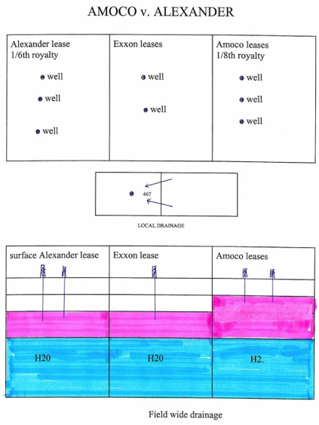
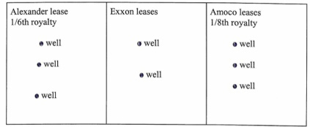
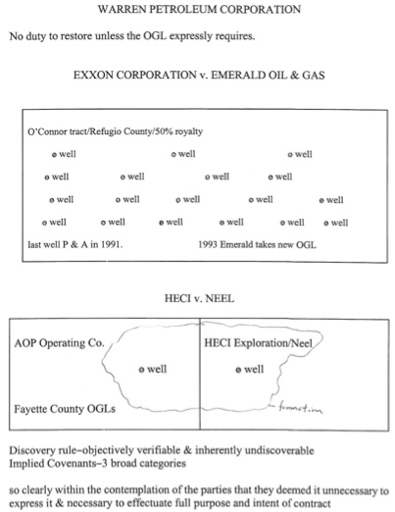
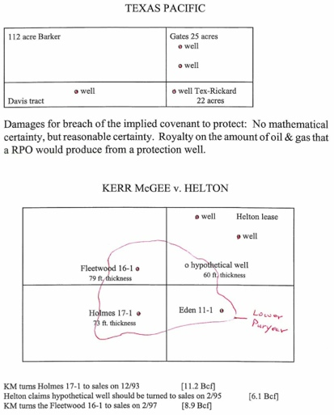
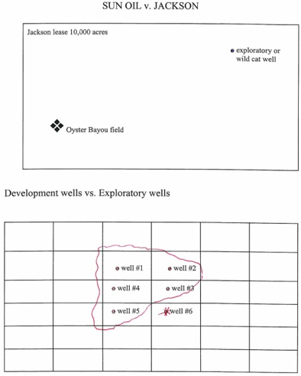
Implied Covenants
p224 AMOCO v. Alexander
Warren v. Monzingo, 235
Exxon v. Emerald OG 237
HECI v. Neel 242
p250, 254 TX Pacific
Kerr McGee v. Hilton
P247 Sun Oil v. Jackson

- Definition: Unwritten promises that impose duties on lessee & protect lessor
  - 2 of them work the other way (from lessor to lessee)
    - Implied covenant of good title
    - Implied covenant of quiet enjoyment
- Arise from: Relationship of the parties & the objectives of the OGL

- 3 TX Categories of Implied Covenants !!!
  - To protect
  - To develop Not to explore
  - To manage & administer

- Common Litigation Issues
  - Drainage
  - Reasonable development & further exploration
  - Marketing
  - Proper operation

- Standard: Reasonably prudent operator (RPO) (profit motive, due regard, not a fiduciary) !!!
- Requirement for a COA: Show operator would make a profit (objective)
- Test: Would a RPO have addressed it? Is it so essential to carry out the purposes of the K? !!!
- COA’s may arise: Operator violates RRC Order
- Allowed: Can act in his own self interest but must act in good faith & competently & w/ due regard for lessor’s interests !!!
- Not allowed
  - Self-dealing
  - Can’t take advantage of lessor
  - Can’t prefer one lessor over another

- Discovery Rule Mostly abandoned bc almost everything in OG is discoverable
  - Objectively verifiable &
  - Inherently undiscoverable
- Rationale: No mention in lease of underlying obligation to achieve the goals of lease. Royalties for lessor w/in revenues
  - Mutual benefit from development for lessee
  - Effectuate parties intent
- Doctrinal basis
  - 1. Intent
  - 2. Good Faith
  - 3. Relationship of parties
  - 4. Implied in fact (or in law?) EX: Implied in fact → jury decides (see supplement, 49)
  - 5. Policy: Prevent waste (leaving OG in the ground)
  - 6. TX cases: Effectuate intent of parties or Implied out of necessity

Duty to Protect
- Requirements for failing to Drill !!!
  - Substantial drainage &
  - Specific DAS &
  - Probability of Profit
    - Definition: A probability that production would cover drilling costs + yield a reasonable profit
  - Standard: RPO. Don’t consider other tracts Alexander

- Covenant to Protect against Drainage: Applies to Local & Field-wide drainage Alexander

- Notice: Only req’d if in lease. Must give notice to cancellation
- Lease Provisions
  - Delay rentals: Doesn’t effect COA
  - Express offset
  - Applies: Only in PT Common lessee → It’s overridden
  - Pooling: Pooling can satisfy the implied covenant to protect (forced or voluntary)

Duty to Develop (Implied Covenant of Reasonable Development)
- Arises when: OG co drills a producer !!!
- Effect: Lessor can argue a RPO would drill another well
- Requirement: Reasonable probability of profit
- EX: Drill well at top of reservoir & it produces. RPO might drill another to increase revenue.
- A. Drill initial well - measured by RPO standard (if you don’t think you can make a profit, you don’t have to do it)
- B. Reasonable Development
  - 1. Lessor's royalty
  - 2. Rate of development-- Issue EX: Drill one well in reservoir well drain it in long time but lessor gives notice
  - 3. Requirement of Notice to impose further obligation
  - 4. Proof of productive horizon
  - 5. Profitability
  - 6. Unreasonable delay in developing
  - 7. Remedy: DAS or Cancellation`
  - 8. Express clauses- Delay rental clause excuses covenant to develop but yields to implied covenant to protect from drainage.
    - No implied covenant if expressly addressed the subject

- Problem: Duty to Develop | Answer
OGL requires you to drill a well & assign 160 acres to it but you must pay delay rentals on the rest. | i.e. Must pay delay rentals on remaining 480 acres the next year, if that’s what remains on the lease
A conveyed Blackacre to B reserving a ½ NPRI. Years later, X Oil leases A & B’s interest w/ 1/8 royalty. A signs a division order that says A gets 1/16 royalty (1/2 of 1/8) but A was really entitled to a ½ royalty (1/2 of 8/8). Who can A recover from? | A can recover from X Oil based on the Gavenda qualification. When a lessee is unjustly enriched by an erroneous division order, the underpaid royalty O can recover from the lessee.

Duty to Manage & Administer
- Duty to seek Favorable Administrative Action (Rule 37) Amoco, Alexander
- Duty to Prudently Operate & administer leasehold
- Duty to Market
  - Gas -- diligence in finding market
  - Shut-in-- if limited it may satisfy. Must be capable of production in paying quantities
  - Price -- good faith
  - Applies: Once production ends
  - Triggers: UCC Art 2 Sale of Goods

No Duty to Restore
- Rule: No duty to restore unless expressly req’d by the lease Warren Pet. v. Monzingo, 235

No Duty to Notify Lessor of COAs
- Rule: No implied covenant for OG Co to notify lessor of litigation it’s involved in (Irrelevant if lessor might be an interested party)
- Reason: Objectively verifiable & inherently discoverable (Discovery Rule) HECI v. Neel, 242
- Problem: Cost prohibitive bc lessor must hire a petroleum engineer to research it at RRC
- Solution: Create an express covenant that says OG co must disclose

No Duty to Explore
- Rule: No duty to explore Sun Oil v. Jackson, 247
- Effect: Don’t have to drill in areas that don’t appear profitable.
- Exploration vs. Development: Presence of known reserves
  - Continuous Development Clause
    - Purpose: Can make a duty to explore in TX
    - Effect: If production → Lessee must continually develop w/ max 120 days bw well drilling. If they don’t, they have to release from the lease all acreage except 40 acres around an oil well and 640 acres (+10%) for a gas well
- 3 categories of wells: Initial, Developmental, & Exploratory
  - Must have profit - no duty of further exploration

- Might extend §oL’s
  - Duty to speak &
  - Intends you to rely on it &
  - You do rely on it

- Price Strip: Expected future price (ie 6%)

Remedies for breaches of an implied covenant
- 1. $ DAMAGES
- One Satisfaction Rule: Can’t get DAS for drainage then receive royalties if lessee later drills (no double recovery)
- DAS for Breach of an Implied Covenant to Reasonably Develop
  - Measured by: Estimating interest on the potential royalties
  - Not producing enough can breach the covenant (even if there’s production that holds the OGL)

- DAS for breach of Implied Covenant to Protect TX Pacific v. Barker, 250
    - Requirements for COA
      - Substantial drainage of lessors land & Geology
      - RPO would drill an offset well &
      - DAS to a reasonable certainty
  - Lessor must show they’ve been deprived. Hard bc lessee has these facts
  - Measured by: Royalty on amount of OG a RPO would produce from a protection well
    - Amount of royalties a lessor would have received if lessee took reasonable action to protect

- 2. ALTERNATIVE DECREE
- Remedy: Ct gives lessee time to correct breach before terminating Perkins v. Mitchell, 262
- Policy: TX avoids breaking leases for covenant breaches

- 3. TERMINATION
- Ct can enter decree of cancellation (last resort) if you don’t drill w/in 180 days (like RPO) Perkins

- PERSONS ELIGBLE TO SUE
- Rule: ORI O has standing to sue the leasehold interest holder Bolton v. Coats, 263
- Lessors: Lessor’s really aren’t part of covenants, but in theory be sued on covenants
- ORI holders: Don’t really have an interest in the land. Do have privity of estate. Depends on breach

- Compensatory Royalty
  - Definition: Royalty for OG lying under one’s property that one is entitled to receive royalties on
  - Applies: When lessee can’t operate on the surface or well location not as good of an option as off the land drilling to get to the same OG, so OG Co offers compensatory royalties (to increase their gain, but still compensates royalty O)

- Divisibility & Indivisibility Cosden
  - Rule: Implied covenants in TX are divisible
  - But implied covenants to develop are different: Must produce and RPO standard
  - Lease stands or fails as a whole, but implied covenants can be breached to some land owners and not others under same lease
  - Some CtApps have given alternative to decrees to some lessors

- Problem: Remedies for Breach of an Implied Covenant | Answer
Neighbors drain B. B gets DAS for production of hypothetical well. What happens if lessee then drills? | Can’t get royalties bc 1 satisfaction rule
Lessor & Lessee sign an OGL lease. Later, lessee assigns it to another person but reserves ORI. Who can the original lessee sue? | He can sue the lessor b/c under Bolton, the ORI owner has standing to sue the leasehold interest holder

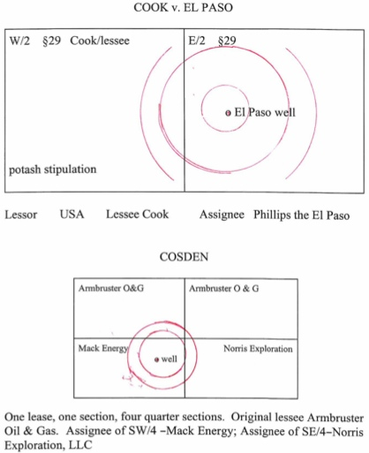
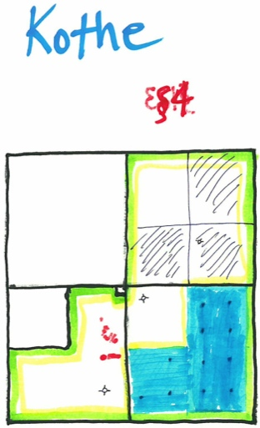
p265 Cook v. El Paso
p271 Kothe Illustration

Special OGL Clauses

Cut-Down Clause (Proportionate Reduction Clause)
- Reason to Use: Sometimes lessors own less than they think
- Applies: If lessor owns less land or minerals than given on the lease
- Effect: Reduce royalties or other payments proportionately
- Advantage: Protects lessee from paying double royalty when they discover a title issue.
- Disadvantage: Lessee might incorrectly think they can cut-down, causing them to underpay delay rentals (forfeits lease)
- Solution: Net rental clause. Shows rental was intended to be paid in full. If later learn title interests were diff, can agree to pay back lessee for that portion
- Example: 2nd sentence back of OGL

- Problem: Cut-Down Clause | Answer
- Dad had two wives, both dead. Child A & B are from 1st wives. Child C is from 2nd wife. | It stops a child from claiming delay rentals for the entire tract. The clause proportions it among the children, preventing this. 1 child can sign & take a copy to others to ratify their proportions

Mother Hubbard Clause (Cover-All Clause)
- Definition: A general clause that conveys all ORI’s in a county… Moore v. Greer
- Example: “The lease also covers adjacent or contiguous tracts owned or claimed by lessor.”
- Purpose: Make inadvertent omissions of small strips subject to the lease (bc incorrect description, AP, survey error, easement, etc)
- Reason for Use: Lessors might own more land than they think. Lessee wants the option to drill it.
- Applies (How it works)
  - Picks up strips of land contiguous to lessor’s property that they hold title to.
  - Only on tracts unknown to the parties. Not covered if lessor knows he owns it
  - Mineral deeds are often more ambiguous than leases & will contain county-wide Mother Hubbard Clauses. They don’t give you huge tracts
- Doesn't Apply: Large contiguous tracts

Property Concepts

Minerals & Other Minerals
Nature of Ownership
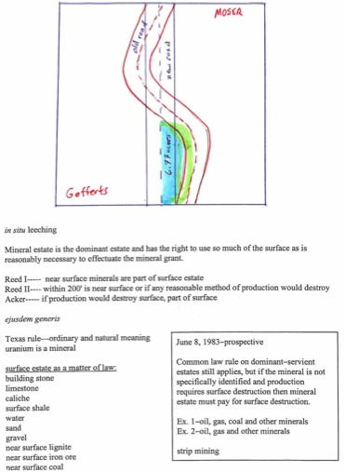
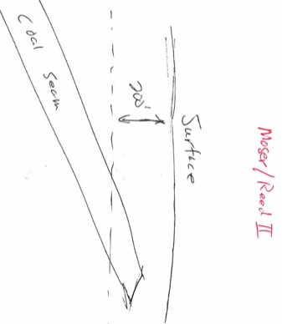
p292 Moser v US Steel
p292 Moser- Reed II

Oil, Gas, & Other Minerals (TX) Moser v. US Steel
  - Rule: A severance of minerals in an “O, G, or other minerals” clause includes all substances w/in their ordinary & natural meaning, irrelevant of whether their presence or value was known at time of conveyance !!!
  - Includes: Uranium, coal, gold, iron & helium

Surface Minerals (Surface Estate as a Matter of Law)
  - Look for: Building materials
  - Examples: Building stone, limestone, caliche, surface shale, water, sand, gravel,
  - Near surface lignite, near surface iron ore, Near surface coal
  - Irrelevant how close they are to the surface

- General Rule: Mineral estate is the dominant estate & has the right to use so much of the surface as is reasonably necessary to effectuate the mineral grant !!!
- Exception: Liable for negligent damage to surface
- History
  - Reed I: Near surface minerals are part of the surface estate
  - Reed II: w/in 200” is near surface or if any reasonable method of productions would destroy
  - Acker: If production would destroy surface, part of surface

Acquisition of Title
- Greatest Possible Estate Rule Property Code 5.001
  - Rule: A land estate that’s conveyed or devised is a FSA unless limited by express words or unless a lesser estate is conveyed or devised by construction or operation of law. CL word req’ts to transfer a FS estate aren’t necessary.
  - Applies: Only to a conveyance after 1840
  - Nutshell: Land conveyed is FSA unless otherwise stated Loomis v. Gulf Oil, 307
  - Effect: Can convey FSA even if you don’t own the minerals

- Failing as a Conveyance Property Code 5.002
  - Instrument intends to convey real property/interest & wholly/partly fails → Enforce to extent permitted by K law

- Partial Conveyance Property Code 5.003
  - Alienation of real property that purports to transfer a greater right or estate in the property than the person making the alienation may lawfully transfer alienates only the right or estate that the person may convey.
  - Doesn’t affect Remainder: Alienation by deed, will of an estate that a remainder depends, union of estate w/ an inheritance
- Form Property Code 5.022
  - Covenant of warranty not req’d in a conveyance
  - Can insert any clause or use any form that’s legal
  - Example form that conveys a FSA estate in real property w/ a covenant of general warranty:
    - "The State of Texas, "County of _____
    - "Know all men by these presents, That I, ___, of ___ (city, county), in the state aforesaid, for and in consideration of $___, to me in hand paid by ___ have granted, sold, and conveyed, and by these presents do grant, sell, and convey unto the said ___ of the ___ (city, county), in ___ (state) all that certain ___ (describe premises). To have and to hold the above described premises, together with all and singular the rights and appurtenances thereto in any wise belonging, unto the said ___, his heirs or assigns forever. And I do hereby bind myself, my heirs, executors, and administrators to warrant and forever defend all and singular the said premises unto the said ___ his heirs, and assigns, against every person whomsoever, lawfully claiming or to claim the same…
    - "Witness my hand, this ___ day of ___ A.D. 19___.
    - "Signed and delivered in the presence of ___”

Separation of Minerals from Surface
- Ways to sever mineral estate from surface estate
  - Reservation EX: Grant FSA but reserve surface
  - Mineral Deed
  - OGL
  - Divorce decree
  - Imminent domain
  - Adverse Possession

Loss of Title
Abandonment
- Real Property
  - TX Rule: Can’t abandon real property
  - Effect: A mineral estate is real property so it can’t be abandoned
- Oil & Gas
  - Rule: Once oil or gas is captured it is tangible property. Can’t lose unless abandoned
  - Requirements: Intent to abandon & corresponding act shows intent
  - Only way to hold the mineral estate is by production (FSD Determines) Pool
    - Aka: Possible to own mineral estate after severance. Must produce to do so.

Adverse Possession
- Requirements !!!
  - Open
  - Continuous
  - Exclusive EX: Keep others out
  - Adverse
  - Notorious EX: Community knows it’s yours
  - Entry before or after severance

  - Best to say “I thought it was my property” to obtain AP. Don’t say, “I was trying to claim it”
  - Continued operation of OGL after termination can ripen title to the working interest !!!
  - After the mineral estate is severed, AP of the mineral estate can only ripen into title through actual occupation of the mineral estate. The req’d occupation is by and through production. Constructive occupation such as drilling & production on a pooled unit, but not on the subject premises, will not suffice. Must occupy the property claimed !!!

- Tacking (Naked AP) Houston Oil Co of TX v. Moss, 324
  - Rule: Can have successive AP’s. Beginning date of AP is the key date.
  - §oL: 10 years.
  - Applies: They collectively assert a common title against a 3P whom had adequate notice.
  - EX: Teddie goes on it for 3 years, conveys to Freddie who stays for 4 & he conveys to Corbin who possessed for 3 years
  - Purpose: Protects property O’s

Dormant Mineral Interests Acts
- Don’t recognize in TX bc can’t abandon real property here. We recognize receivership instead. When you file a receivership action, some people will try to track the people down so they can get a NPRI from OilCo. Texaco v. Short, 327
- Effect: Severed mineral interest that’s not used for 20 years automatically lapses & reverts to the current surface O
- Use: production, payment of rents, royalties, pay taxes, etc

Leases from Unlocatable or Contingent O’s
- Receivership Statute pg 203
  - Purpose: Ct executes a receiver on behalf of the OG mineral interest O’s
  - Applies: Descendant owned a mineral interest. Several generations later, OG co can’t find mineral interest heirs
  - Minority (Not TX): Some states will merge mineral & land ownership
  - Where does the $ go? Held by clerk. If receiver doesn’t pick it up soon enough → Escheat

- Receiver for Mineral Interests Owned by Nonresident or Absentee 64.091
  - Purpose: Encourage exploration & development
  - Applies
    - Action brought by a person claiming or owning an undivided mineral or leasehold interest in TX land & 1+ ∆’s who have, claim, or own the same or
  - ∆ for whom the receiver is sought must
    - Identity/residence unknown or nonresident &
    - Not paid interest taxes for 5 yrs
  - Π-receive must allege & prove he
    - Diligently & unsuccessfully tried to locate ∆ &
    - Substantial damage or injury unless receiver appointed
    - Identify ∆ as the last known interest O
    - Give ∆ notice in publication
      - Ct: Receiver can be judge or county resident. Bond not req’d
  - Duration: Until ∆/∆’s heirs claim the interest
  - Duties of Receiver
    - Execute & deliver mineral leases to lessee/successors (on outstanding undivided interests) or
    - An assignment & enter a unitization agreement
    - May authorize lessee to pool & unitize land w/ adjacent land into a unit (see RRC limits)
  - May execute OGL, assignment, or unitization agreement
  - $ to clerk. It goes toward costs & balance for nonresident or person of unknown residence who owns the mineral or leasehold interest. Later payments are impounded for the use and benefit of the mineral/leasehold owner
  - Removal of Receiver: Same as other laws

- Mineral lease - OGL that contains provisions necessary or incident to the orderly exploration, development, & recovery of them
- Leasehold interest - Ownership created under a mineral lease or carved out of a leasehold estate granted under a mineral lease, including production payments, ORI, & working interests
- Lessee - An assignee under an assignment of a mineral lease.

- To Appoint a Receiver for Contingent Interests in Minerals CPR 64.092
  - Receivership Requirements
    - Susceptible to drainage or
    - OGL investment will benefit those entitled or
    - OGL necessary to conserve, preserve, or protect the land or estate or of any interest in it
  - Receiver may: Lease land for OGL development & Receive, hold, & invest proceeds to benefit those entitled
  - Requirements for land under an OGL & subject to a contingent future interest
    - Pooling not in lease or they’re ineffective as to the contingent future interest &
    - Necessary to protect correlative rights or prevent waste or conserve, preserve, or protect land interest &
    - Benefits future interest holder
  - Who can apply for Receivership: Lessee or their assignee
  - Receiver can
    - Amend OGL to authorize pooling for the contingent future interest & for add’l consideration &
    - Receive, hold, and invest it to benefit those entitled
  - Ct can give receiver all powers necessary to exercise their authority
  - May authorize lessee to pool & unitize land w/ adjacent land into a unit (see RRC limits)
  - Not a necessary party if: Their interest subject to pooling & not seeking to enlarge their interest
  - Discharging a Receiver: Ct may order later payments accruing to the contingent future interest be deposited
  - Doesn’t Apply: Land subject to existing homestead rights → Homestead O must give written consent to convey
  - Contingent future interest: Legal or equitable interest arising by remainder, reversion, possibility of reverter, executory devise, on the occurrence of a condition subsequent

Partial Estates (Divided Ownership)
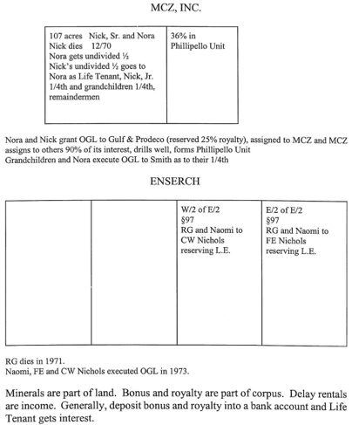
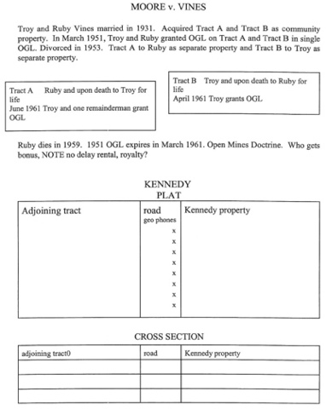
p341 MCZ Inc v Smith
p342 Ensearch Exp v Wimmer
p348 Moore v Vines

- 2 Types of Divided Estates: Co-tenancy & Successive (Life Estates & Remaindermen)

Co-tenants (Tenancy in Common)
- Accounting for Co-tenant (TX)
  - Rule: Any cotenant can enter the property to convert, drill, & sell the gas, but they must account for the net proceeds to the other co-tenant
  - Co-tenants have an undivided interest throughout the property EX: Like CP
  - Co-tenant can’t acquire property via AP EX: No AP even if raise goats on it for 25 years
  - Co-tenant doesn’t have to have co-tenants permission to produce Burnham v. Hardy, 336

Types of Co-tenants
- Operating co-tenant (developing co-tenant)
  - Not royalty O’s, must account for operating expenses
  - Discovers OG → Can bring them to the surface, sever, & sell it
    - Must account for proportionate share of net profits (pro-rata basis)
  - Must have net profits to assess costs to non-operating co-tenant See accounting for co-tenant, 56 (figures) !!!
  - Bears entire risk EX: Dry hole → Loses all costs
  - Dealing w/ non-consenting co-tenant
    - Pay-out: Income once the co-tenants share of the cost of drilling, equipping and completing the well is paid out
    - Alternative Options
      - Forced Pooling: Can apply for a forced pooling order from the RRC or an order under the muscle-in clause
      - Joint Operations under JOA: Can enter JOA to share costs & accounting
      - Partition
        - Rule: Co-tenants have right to partition (inequities irrelevant)
        - Requirement: Estates of equal dignity EX: FSA = FSA
        - 2 Types of Partition: Partition in Kind or Partition in Proceeds !!!
        - Owelty: Partitioning co-tenant may have to pay % of value EX: Must pay 25% value

- Non-operating co-tenant (non-consenting co-tenant)
  - Royalty O’s, don’t have to pay operating expenses
  - Carried Interest to Payout: Can’t recover profit until operating co-tenant recoups his proportionate share of expenses !!!

Successive Ownership: Life Estates & Remaindermen
- Rule: Life tenant & remainderman must have joinder w/ one another to grant an OGL
- Requirement: Joinder
- Nutshell: Both are necessary parties to the OGL
- Reason: Remainderman has no present right to possession

- How trustee should account for interest $ TPC 116.174
  - Who gets the $?
    - Principal or Corpus → Remainderman
      - Bonus (corpus) → Deposit into account → Principal to LT when R-man dies
      - Royalties (corpus) → Deposit into account → Principal to LT when R-man dies
        - Usually royalty is income, but not here

    - Interest or Current Income → Life Tenant
      - Delay rentals / rent (income)
      - Interest from bonus & royalties → Gets cash when R-man dies
      - Production payment (income if lease provides a factor for interest or its equivalent) Balance to principal.
      - Interest in water that’s renewable (income)

    - Allocate Equitably
      - Working interest, interest in non-renewable water, other interest
      - Royalty, shut-in-well payment, take-or-pay payment, or bonus

  - 2 Exceptions what’s the difference ???
    - Agreement: Can agree to change how to divide lease benefits
    - Open Mines Doctrine: Can change how to divide lease benefits by law
      - If mine opened before LE created → LT entitled to all production from it (a.l.a. prior lease in effect)
      - 1st production doesn’t have to pre-date the LE
      - Doesn’t Apply: If lease in effect when LE created but it expired (can’ apply to new lease or extension)

  - Applies: Irrelevant if decedent or donor extracted before the interest became subject to the trust
  - Equitable when: Principal = amount allowed by IRC as a deduction for interest depletion

- Summary
  - OGL begins during PT & lessee drills during it, resulting in production → Life tenant gets royalty
  - OGL PT ends w/out joinder of remaindermen → Royalty goes to depository account. Interest to life tenant
    - Can’t deplete corpus (that’s why royalty only)
    - Deplete corpus → Waste
  - Life tenant has right to possession during their life
    - Remainderman enters property during life tenants life → Can sue for trespass
  - Open Mines Doctrine only applies when OGL in effect / during PT/ & production & ???→ Royalty paid to life tenant
    - Sometimes used as an estate planning device to pass LE w/out probate Archer Cty v. Webb
- Won’t satisfy Habendum Clause if it doesn’t provide for constructive production (as in shut in royalty) ???
    - Shut in royalty clause won’t give NRI holder a right to royalty (only being paid to keep lease alive)
      - Actual production req’d to preserve the NRI !!! Moore v. Vines, 348

Terminable Interests
- Term Royalty Deed
  - Definition: Royalty interest conveyed for term of years & so long thereafter as there’s production
  - Terminate like leases, but are independent
  - If it doesn’t allow substitutes for production → Substitute for production won’t keep a royalty deed from terminating (ie, shut in royalties might not help a mineral deed)

Trespass
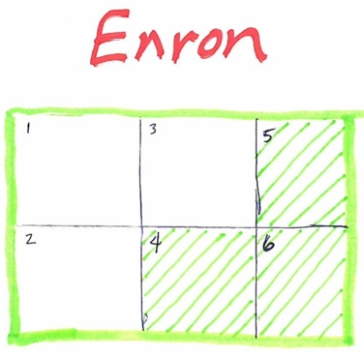
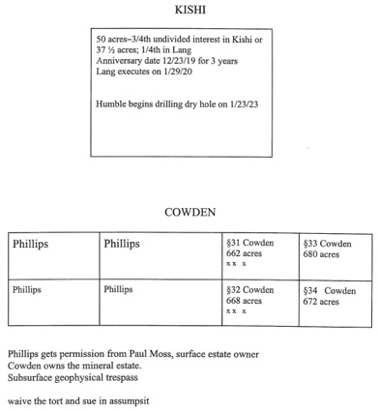
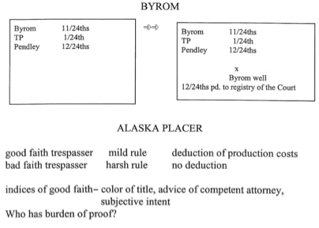
p353 Enron v. Worth
p360 Humble Oil v Kishi
p362 Phillips Pet v. Cowden
p366 Byrom v. Pendley
p369 Alaska Placer Co v Lee

- Requirements
  - Owned or had a lawful right to possess the real property &
  - Trespasser entered upon the land (a) physically, (b) intentionally, & (c) voluntarily &
  - Caused injury
- Defense: Consent or license

Geophysical Trespass
- Geo-Exploration / Seismic
  - Rule: Mineral O has right to conduct seismic operations & he can recover for trespass Phillips Pet. v. Cowden, 326
  - Rule: Mineral O may sever & assign a surface easement to conduct geo-exploration Enron v. Worth, 353
  - Reason: Mineral O has absolute right to enter the property to explore & develop
  - Includes: Right to authorize seismic operations Humble Oil v. Kishi
  - Don’t physically enter the surface & no negligent operation → No right to recover Kennedy v. Gen, 356
  - Requirement: Must enter property to have a claim (not simply around it) Kennedy
  - Seismic permits
    - Grants equal rights of exploration as OGL (TX) but less consideration than an OGL bonus
    - Must meet §oF Phillips
  - Rule: Surface O can’t give permission to a driller or geophysical examiner to conduct geo-exploration
  - To Avoid Trespass: Mineral O must give permission
- Scanning
  - No right to take info from someone else’s land (no DAS for conversion of info)
  - Can scan neighbors of a piece of land & guess what’ s going on (not trespass)
  - Can buy permit from state to conduct geophysical exploration along hwy
  - DAS (TX): Can sue for trespass DAS (reasonable market value of geophysical permit) or assumpsit (implied K theory)
  - Vibrations
    - Mere vibrations from geophysical explorations → Not trespass
    - Damage water wells or home foundation → Can be geophysical trespass damage
- Hydraulic Fracturing: Stimulation of a gas well extends the “well bore” far away from the steel casing of the well. Same effect as a deviated well. Deviated, directional or slant hole wells are the classic case of subsurface trespass.

Physical Trespass
- Good Faith Trespass Byrom v. Pendley, 367 // AL Placer
  - Honest & reasonable belief EX: Have OGL & costs > expenses
  - Result: Keep $ & return title

- Bad Faith Trespass Houston Prod. Co v Mecom Oil, 373
  - During litigation
  - To protect from drainage w/out title but can get Ct order
  - Result: Return title & can’t keep $ (punitive)

- Factors
  - Professional advice
  - Intent
  - Entered under color of title EX: Have OGL & costs > expenses

- Co-tenant Trespass
  - General Rule: Co-tenants can’t trespass on one another
  - Rare Exception: If lease denies cotenants title
  - If co-tenant doesn’t consent to drill, they just elect to not participate in the risk (TX)

- Claim for Improvements TPC 22.021
  - Requirements
    - Good faith AP <1 yr &
    - Made permanent & valuable improvements &
    - Grounds for the claim &
    - Identify improvements &
    - Value of each improvement

  - Rule: ∆ in a trespass to try title action, who’s not the property O, but possessed it in good faith & made permanent, valuable improvements is either:
  - Can recover: Estimated value of improvements − estimated value of use, occupation, waste or other injury to the property or
  - Liable for: Estimated value of use, occupation, waste or other injury to the property − Estimated value of improvements
Not Liable: DAS, injuries or value of use & occupation <2 years before filed or improvements worth more (see can recover)

  - Value of Improvements: Extent they increased value @ time of trial
  - Value of Use and occupation: Valued for the time before action filed that ∆ possessed, excluding value of improvements

Slander of Title
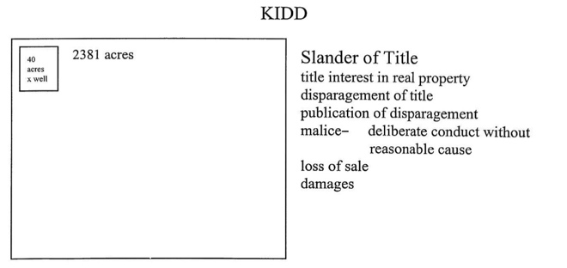
p382 Kidd v. Hoggett

- TX Rule: Lessee has a duty to record that the lease expired Duty in K → Written form prevails
  - Failure to file clouds the title, but isn’t actionable alone Duty not in K → Still a duty
- Requirements
  - Publication: Refusal to release recorded title is a publication
  - Falsity of the Publication
  - Malice
    - Regular Malice: Act or refusal was deliberate conduct w/o a reasonable cause → Good for Actual DAS
    - Actual Malice: A willful or wanton act with an evil motive → Req’d for punitive DAS EX: Greed
- DAS for Slandered Property: Must be loss of a specific sale
Mineral & Royalty Interests

Attributes of the Severed Mineral Estate
- 5 separate essential interests to a severed mineral estate
  - Each is a separate property right. Can be divided from the rest. Bundle of sticks theory applies.
  - If you don’t specify which interests you give → Presume you gave them all
  - Common EX: ORI. Only right to receive royalties, usually just a fraction of it. (ie. ¼ royalties to me, but I can’t do anything)

The Executive Right
Power of the Executive (Mineral O’s)
- Right (but no duty) to take all actions related to leasing & developing the mineral estate
- Can’t enter a pooling agreement w/out non-executive’s consent
- Only one mineral interest holder can have it

Duties of the Executive
- Trigger for Duty: When executive enters a lease
- Test: Scope of duty
  - Would executive enter the same transaction if there wasn’t a non-executive interest?
  - Did executive obtain benefits for himself at the expense of the non-executive interest? Lesley v. VLB

  - EX: 100 acres. Better to take 1/8 + $3,000 or 3/16 + $1,000? Better to take 1/8 + $3,000 (gets $300K vs. 100K)

- Duty of Utmost Good Faith
  - Rule: Executive must act w/ due regard for the non-executive O’s interest & execute leases like a reasonably prudent landowner (like if no non-executive interest)
    - Less than a fiduciary duty. Doesn’t have to subordinate his interest
    - Non-executive interest O depends on good faith of executive right O to lease their interests advantageously
    - Executive must share equally in the benefits, for the royalty O’s any benefit he recovers for himself Manges
    - Don’t exercise right → No duty (but look for unequal benefits) In re Bass, 403
  - Includes
    - Duty to share proportionately w/ the non-executives every benefit the executive receives Handout / Mims v. Beall, 398
    - Duty to not self-deal
    - Duty to not overreach
  - Doesn't Include: Duty to subordinate interests to non-executive
  - Breach: Non-executive can get actual or punitive DAS (best) or remove executive

- Power of Attorney: Can’t give the executive right away w/ power of atty
- Exception: Specifically & expressly stated or universal power of atty

- Severance (Naked Executive Right): An executive right severed from other incidents of mineral ownership is an alienable property right

Rules of Construction
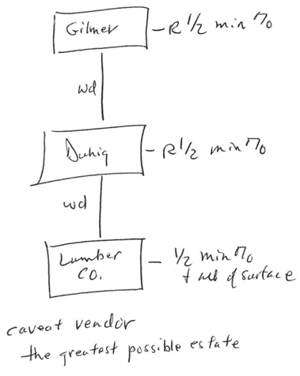
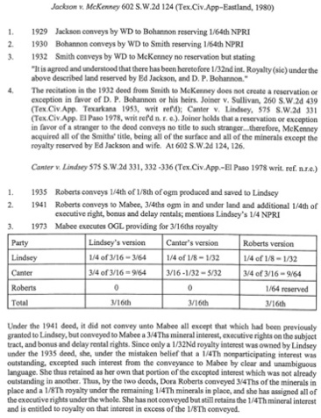
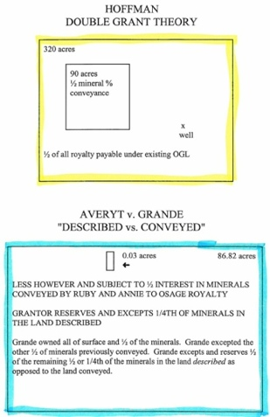
P425 Duhig v. Peavy-Moore Lumbar
P425 Jackson v. McKenney
p436 Hoffman v. Magnolia Petroleum
p443 Averyt v. Grande

The 4 Corners Rule
- Luckel v. White, 413 // See handout p413 deed in Luckel v. White
- Concord v. Pennzoil, 418
- Rule: Look at entire instrument to see if statement standing alone is ambigious. If so, look at whole deed to determine intent
- Problems with fractions
  - Subject to Clause: Don’t need “The above described land is subject to a lease”
  - Present Lease Clause: Don’t need “The present lease covers and includes ½ of minerals”
  - Future Lease Clause: Never need “This deed covers & includes a ½ interest in future leases.”

  - If these are used → Use the same fractions in each part to avoid ambiguity

Estoppel by Deed: “Duhig Rule”
- Rule: Fractional part of bonuses, rentals & royalties received under a mineral lease is usually same as his fractional mineral interest
- Applies: Warranty deed w/ fractional reservations
- Over-Conveyance (Greatest Possible Estate Rule)
  - Rule: If you convey more than you really own, you convey everything you own Duhig v. Peavy Moore, 425
  - Test: What’s the greatest possible estate they can convey to whomever?
  - Effect: Estops grantor from claiming a diff interest later
  - Common Cause: Someone messed up w/ fractions & claims they meant to grant a lesser fraction than they did
  - ROC: Read OGL literally. Intent irrelevant. Errors found to benefit grantee
  - Exception: Reference to another deed can act as parole evidence to show real fractions

- Problems: Greatest Possible Estate Rule | Answer
Convey ½ and reserve 1/4th, but you really only own ½. What result? | Conveys everything you own
Own ½, convey 3/8ths and reserve ¼. What result? | Conveys 3/8ths and reserved 1/8
Only reserves ½. What result? | Conveys ½

- Doctrine of After Acquired Title
  - Applies: If you purport to convey a deed to another party, but you don’t own it EX: didn’t inherit yet
  - Effect: You can’t assert title against them bc estopped from contesting by the prior deed (even if later acquire bona fide title)

EXCEPTION to Duhig #1: Formally Express Intent
- Mineral interests O’s may change it. Must formally express their intent Benge v. Scharbauer, 427

EXCEPTION to Duhig #2: Double Grant Rule & The Subject to Clause
- Rule: An expressly reserved subject to clause refers to another deed. Changes the Duhig analysis. Harris v. Windsor, 431
- Look for: “the conveyance is subject to a ½ interest in a mineral lease”
- Test Tip: Say it changes the Duhig analysis. Show what it would be under Duhig, & what it should be under Harris !!!

- Present lease Hoffman v. Magnolia, 433
  - Problem: If you convey “1/4 of your land subject to a ½ interest in a mineral lease”, it gives grantee ½ interest in entire lease, not just their ¼ of the land.
- Future lease
  - Problem: If you convey “x% in future leases” → It’s forever
  - Solution: Say “this conveyance is subject to said lease insofar as it covers only the amount granted in this conveyance” or say nothing

Terminated Lease
  - Lease Ratification by Accident: A conveyance in a subject to clause can ratify a terminated lease Humble v. Clark, 436

EXCEPTION to Duhig #3: Land Described vs. Land Conveyed
- Rule: Granting clause of the mineral deed must describe what you’re granting & what you reserve
- Fractional reservation of the ”land described”
  - It’s a fraction of everything, a Reservation from the entire estate. If grantor conveys ½ and reserves ¼, grantor reserved ¼.
- Fractional reservation of the “land conveyed”
  - It’s a fraction of what you own, a reservation from what passed in the deed Averyt v. Grande, 439
  - EX: If grantor conveys ½ and reserves ¼ → grantor only reserved 1/8.

“In and Under”
- Royalty v. Mineral Interest Barker v. Levy, 443
  - 1/8 ownership of royalty is 8x more than if you had 1/8 in mineral interest under a 1/8th royalty lease.
  - However, a royalty interest holder with no other interest has no right to delay rentals or other bonuses.
- “In and Under” in a mineral deed
  - If mineral deed conveys an interest in minerals produced “in and under” the land → Conveys a mineral interest
  - If mineral deed omits “in and under” in conveying an interest in minerals produced → Conveys royalty

Special Problems
Non-Apportionment Rule

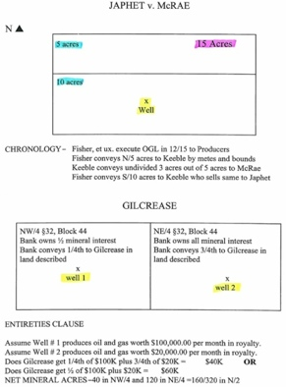
P447 Japhet v. McRae
p450 Thomas Gilcrease Foundation v. Stanolind Oil

- Requirements
  - OGL lease covering all the premises &
  - Meets & bounds partition & EX: “I convey to x the north 5 acres”
  - Well located on part → then O gets all the royalties

- Definition: If there’s an existing lease, & part of the mineral deed is sold to a new party, the royalties only go to the mineral deed O w/ the wells on the land
  - No apportionment bw diff lease O’s absent an express agreement
  - A “subject to” clause can act as an apportionment clause for the grantor & grantee

Entirety Clause
- Definition: A lease in its entirety has the lessee pool the mineral interests & distribute royalty among lessors by acreage %
- Advantage: Relieves lessee from making internal offsets bw lessors
- Disadvantage: Lease covers some areas but not others → Lessee may have to pay <100% bc they must split the acreage % & pay other royalty interests

Rule Against Perpetuities
- Definition: If a future property interest doesn’t necessarily vest within 21 years of a life in being identified in the instrument, the conveyance is void.
- OGL Rule: A royalty deed that becomes effective when the existing lease expires violates RAP (bc lease may never end)
- Ex: Lease signed, then sign top lease that says if they don’t drill within 10 years, then it goes into effect …???
  - How to Avoid: Use a “subject to” current lease clause, bc you have vested ownership in the minerals, you just don’t get royalties until its over
  - Ownership of possibility of reverter is vested ownership now. Irrelevant if never possessed
- Pooling agreements Not effected by RAP bc doesn’t effect real property interest. Since personal property, it’s not effected by RAP.
- Cy Pres Doctrine: RAP subject to Cy-Pres Doctrine: Ct can edit an offending part of a document to achieve its larger goal.
- Solution: “the lease shall become effective upon the expiration of the existing lease, but in no more than 10 yrs from this date”
- Not subject to RAP: Vested reversions, possibilities of reverter, remainders, reserved NPRI
- Rule: Possibility of reverter following a FSD is valid under RAP, even if created by a fictitious re-grant or 2nd instrument
- Reason: Vested from their creation Luecke v. Wallace, 459
- Test: When does the interest vest? (not when it comes into possession) Bagby v. Bredthauer, 455
Business Transactions by Lessee

Lease Assignments
- Rule: Lessees can assign their leases. They can hold an ORI in lease as an assignor. Assignor doesn’t owe any duties to assignee. Suna Pet. v. Parkes, 461
- Wash-out
  - Problem: ORI can be washed out bc dependent upon OGL existence (life of ORI is co-terminus w/ life of OGL) !!!
  - Solution: Renewal & extension clause (creates a new lease)
  - Effect: Prevents the ORI from being washed-out when OGL terminated

Farm-outs
- Definition: Civil K’s a lessee enters where they farm-out their lease duties while retaining a % of royalties Martine v. Darcy, 464
- Occurs when: Lessee acquires so many OGL’s on a property they can’t drill them all
- Solution: Farm them & out say if you drill this, we’ll assign you an interest
- Example: “We agree to assign you a ½ interest in xxx on the condition that you commence a well…”
- There are different …Before Pay-Out (BPO) and After Pay-Out (APO) in a farm out agreement

Joint Operating Agreement (JOA)
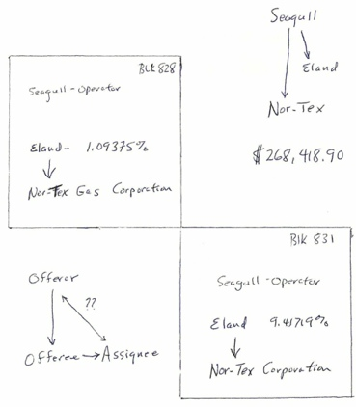
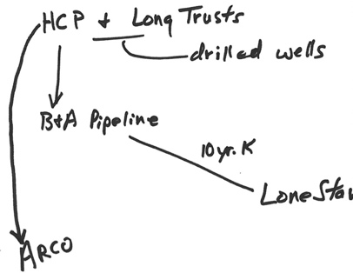
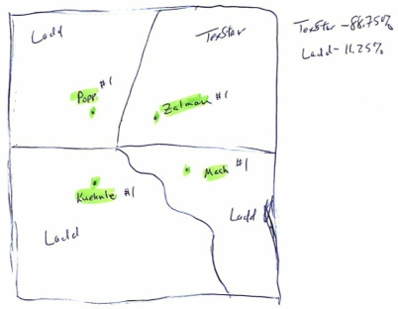
P501 Seagull Energy v. Eland Energy
P492 Long Trusts v. Griffin (ARCO)
-482 Texstar v. Ladd

- Dry Hold Contribution Letter: D gets a dry hole contribution letter from A BC E that says something like “each owes 15% of the cost if it is a dry hole. If it’s a producer they don’t owe anything”

- Definition: An agreement b/w lessees to jointly operate a property (similar to co-tenancy)
- Purpose: Decide who will do the physical working of the wells
- Most popular one in use: American Assoc. Of Petroleum Landmen (AAPL) Model operating agreement
- Disadvantage of Partnership: Liability. Non-operators who are solely investors don’t lose more than they invest if breach promise
- TX Rule
  - JOA’s not corporations or partnerships. They’re their own legal entity.
  - Charges among operators vary by what they agreed to pay. Each might get diff prices for their OG, only some might profit
- General: Expressly disclaims a partnership (prevents liability for partners debts)
- Includes
  - §oF
  - Waiver of right to partition
  - Preferential right to purchase EX: Prevent O from selling to another OilCo
  - IRS, Force Majeure Clause, Claims & Lawsuits, etc
- Operator
  - 1 operator, usually has largest interest
  - Divides all expenses & bills based on their fractional interest
  - Duties
    - Standard: Reasonably Prudent Operator (RPO)
    - If RPO would purse a claim against a 3P → Operator liable to non-operators if he doesn’t do so.
    - If RPO wouldn’t pursue → he doesn’t have to either.
    - Not reasonable to make $ off the non-operators except a fee

- Non-operators
  - Usually investors w/o an active role
  - Production is shared in proportion to the amount of interest in the operating agreement
  - Duties
    - No covenant of good faith & fair dealing implied in an operating agreement
    - Don't need a just cause to refuse to consent
- Must meet §oF: Must describe interest in land w/ reasonable certainty

- Transfer of Operating interest
- Rule: Can transfer operating interests
- Lien Problems: Not recorded like leases. Can purchase w/out knowing it’s subject to a lien. Must still pay.
- Duties
  - Must see if other parties to the operating interest want to buy your share before selling to a 3P
  - If new party in JOA doesn’t live up to agreement → Previous O’s contingently liable for new party
  - Can try to get a release to avoid liability, but still liable if new party breaches

- Authority for Expenditures (AFE)
  - Purpose: Operator sends AFE to get consent of all parties. Gives an estimate of the unit cost
  - Can’t w/draw consent after AFE signed if expenses are necessary & reasonable

- Going Non-Consent
  - Definition: Non-operators can decide not to consent to contributing to the costs in the AFE (can refuse to sign)
  - Effect: Doesn’t bear cost risk of a dry hole
  - Disadvantage: Can tank a whole operation, preventing profit
  - Solution: Non-Consent Penalties
    - Purpose: An incentive to invest (not a true penalty)
    - Upon production of a producing well, non-consenting party doesn’t take their share of profits out of the operating agreement until 100% of production costs they should have agreed to are subtracted from what would have been their share of production.

Drilling K’s
- Applies: Lessee’s can indemnify themselves from negligence of the drilling co. they hire. But lessees can’t indemnify themselves from their own negligence as it pertains to the drilling
- Texas Codified Express Negligence Doctrine Getty Oil v. Insur. Co of N. America, 512
  - Rule: Lessee can’t indemnify himself, no exceptions
  - If he tries to → Agreement void
  - Can be insured, max $500,000
  - Operator’s indemnity in a JOA → Not really indemnity, just that liability is spread proportionally

White Oil (Hydrocarbon Liquids)
Problem: TRC classifies wells as oil or gas by how many barrels of oil are produced per cubic feet of gas
- Solution: Can refrigerate some gasses, like casing head gas, and turn it into oil (aka white oil) Amarillo Oil v. Energy-Agri, 512
- Allowed bc: Calculate amount before severance, not after freezing
Pooling & Unitization

- Look for: “Lessee is granted the right, at its option, to pool or unitize any land covered by this lease w/ any other land covered by this lease, and/or with any other land, lease, or leases, as to any or all minerals or horizons, so as to establish units...Lessee shall exercise said option… by executing an instrument identifying such unit and filing it …in the public records office. Each of said options may be executed by Lessee at any time and from time to time while this lease is in force, and whether before or after production has been obtained either on said land or on the portion… included in the unit, or on other land unitized herewith. A unit established hereunder shall be valid and effective…even though there may be mineral, royalty, or leasehold interests in lands w/in the unit, which are not effectively pooled or unitized. Any operations conducted on any part of such unitized land shall be considered, for all purposes, except the payment of royalty, operations conducted upon said land under this lease...”
- How to Pool
  - Voluntary Pooling (Pooling Clause)
  - Community Lease
  - Pugh Clause
  - Compulsory Pooling

- Suits involving pooling
  - If someone contests whether pooling is valid, there are always 2 parties w/ the same motives:
    - Party w/ a well says there’s no pooling bc they want the $ &
    - Party w/out a well says pooling valid bc otherwise they get no $

- 2 Basic Uses for Pooling
  - One Well Unit: Create enough acreage together for a well (b/c of RRC spacing Rule 37)
  - Field Wide Unit
    - If unit is already in place: Pool bc reservoir eventually needs injection wells to increase production. Some wells converted into saltwater injection wells. Others still pump oil. Sometimes called unitization, terms interchangeable.
    - If unit not already in place: Ensures you get something
    - Provides flexibility & power to lessee. Lessee is able to instantaneously locate production on an OGL w/ the stroke of a pen. Habendum clause satisfied & OGL maintained into its secondary term. !!!

- Allocation Formula: [Tract acreage ÷ unit acreage] × Royalty = … × total proceeds of production

- 3 Common Pooling Clause Situations
- Scenario: All leases are 1/5 royalty and all expire 2 days from now…
  - Type A see type A on pooling scenarios.pdf
    - Applies: Lease is included in the unit & well not on lease
    - It’s a paid up lease so no delay rental issue. All of these expire on 4/19 so he runs to the commission to pool these. Bc the pooling provision says “operations on any unit is the same as operations on any of the units” Lease 9 has 80 acres, 15 acres in included in the unit…
    - Formula: [15 acres ÷ 160] × [1/5] =15/800ths × total proceeds of production
    - The whole lease is held but you ‘re only entitled to 15/800ths royalty

  - Type B
    - Applies: Well is on the lease and it’s all included in the unit (parts of all leases are w/in the unit)
    - Pooling provision says you can include other lands in the unit and you get your …which is the unit acreage
    - Formula: [40 ÷ 320] × [1/5] = 1/40th × total proceeds of production
    - Thus operations on tract 8 is operations on tract 2, etc

  - Type C
    - Applies: Well is on the lease, and only part of the lease is included in the unit
    - Formula: [35 ÷ 320] × [1/5] = 35/1600 × total proceeds of production

- Escape Clause
  - Look for: “provided, if gov’t has jsd over units….permitted & prescribes”
  - Today it’s permitted & prescribed
  - Not prescribed by OGL → Breaches OGL → May cause termination bc can’t rely on the pooling provision to provide for “operations on the lease” so if you don’t have operations, you’re no longer supported by the pooling provision
  - When strictly construed, the pooling power is limited from its broad powers
- Rule: Unit gas can’t make a pooled unit retroactive Tittizer v. Union Gas Corp., 524
  - File at clerks office
  - Pooling can discharge the implied covenant to protect
  - Must show substantial drainage & profit for have duty to protect DAS !!!
  - Only include productive acreage w/in the pooled unit

Voluntary Pooling

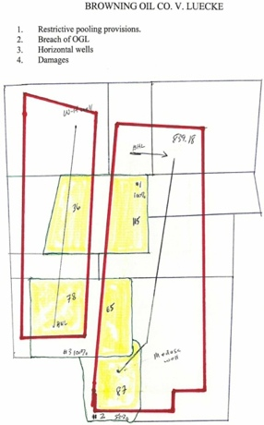
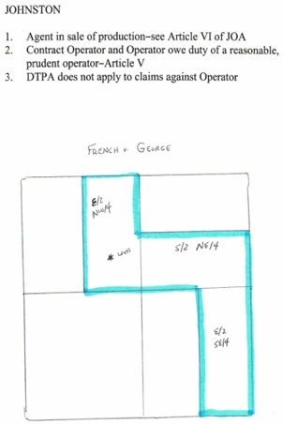
P538 Browing Oil v. Luecke

P558 French v. George

The Lease Pooling Power
- Effect of something???: Unit is void abenitio, can’t get royalty back, and have to pay drill site tract 100%
- Rule: Executive has no authority to pool the NPRI (If he does → Lessor can ratify) !!! London v. Merriman, 536

- Pooling Clause
  - Authorizes lessee to pool leased premises w/ other lands on both his & lessor’s behalf to create an operating unit
  - A form of voluntary pooling. Lessee has no contractual authority to pool the lessor’s interest (unless express), but lessee may obtain a compulsory pooling order

- Limiting the Pool
  - Clause can limit the acreage lessee’s allowed to pool
  - Post-lease voluntary pooling agreement that exceeds what agreement allows → Agreement is voided
- Expanding the Pool
  - Look for: “expand unit to reach maximum production allowable by well”
  - Effect: Lessee can go beyond the set amount of acreage in pooling clause

- Lessee’s Pooling Power
  - Rebuttable Presumption: Good faith
  - Bad Faith Factors
    - Pools after production started
    - Pooling just before lease terminates to save the lease
    - Dilution pooling (adding a lessor b/c it dilutes royalty payouts)
    - Gerrymandering Pooling
    - Perpetuating too much acreage (a pooled lease w/ well near property lines to keep a large tract open with only one well)
    - Knowing inclusion of non-producing acreage
  - Effect if Bad Faith: Pooling unit void

- Ratification
  - By Lessor w/ Executive Right
    - Can enter leases
    - But! Can’t enter into pooling agreements w/out non-executives consent
      - If violated, lessor can
        - Ratify the pooling agreement and it’s valid or
        - Refuse to ratify the agreement, then the agreement is out
  - By Lessee
    - Lessee can’t take part in pooling w/out lessor’s consent
    - But! lessor can ratify the pooling agreement after the fact
    - If lessor doesn’t want to ratify the agreement → They can bget DAS for any production on their land that occurred while the invalid pooling agreement was in place
- Pooling is separate from Leases
  - If a lease is placed w/in a pooling unit while pooling power and lease are valid & lease later terminates → Pooling agreement continues. Termination of a party’s lease doesn’t terminate participation in a pooling unit.

Community Lease
- How to make it: Describe all the land in paragraph 1 & have the community sign
- Implied Pooling
  - Presumption: Strong presumption in TX that parties intend to pool (even if no pooling agreement)
  - Applies: Several tracts on same OGL
  - Effect: Royalties split by acreage (regardless of where well ends up)

Pugh Clause (protects lessor)
- Look for: “After the PT, pooled units will not hold the lease in force for the unpooled areas”
- Effect: Stops perpetuating big pooled leases w/ one well. Limits pooling area remains to current well. The rest is released from OGL
- Rule when no Pugh Clause Wells v. Continental Oil, 587
  - OGL indivisible by nature & operations/production anywhere on the lease is production everywhere
  - Maintains OGL if it’s included on that pooled unit
  - Can mean one well on a pooled lease can hold huge acreage

Anti-Dilution Clause (protects lessor)
- Problem: If there’s an Anti-dilution Clause, one way to resolve it is to use a release provision
- Solution: Most OGL’s contain a release provision to release the rest of the acreage (get rid of it) HS Resources v. Wingate

Compulsory Pooling

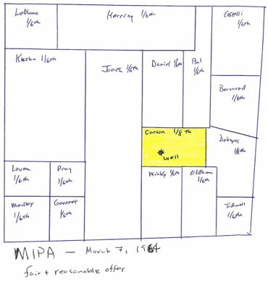
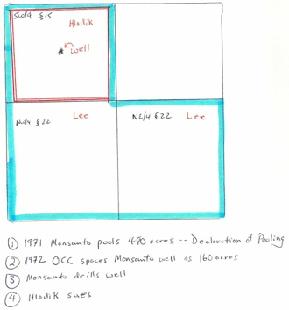
p578 Carson v. RRC
p584 Hladik v. Lee

- Rule 37 Minimum Distance Requirements
  - Trigger: Rule 37 attaches when you discover OG Ryan Pet. v. Pickens, 572 link
  - Can’t drill nearer than 1,200 feet of any well completed in or drilling to the same horizon on the same tract or farm
  - Can’t drill nearer than 467 feet of any property line, lease line, or subdivision line.
  - For standard development on a pattern of 1 well to each 40 acres in areas where proration units not est.
  - RRC can grant exceptions if necessary to prevent waste or to prevent the confiscation of property

- Who can request: Persons w/ a mineral interest

- 5 Necessary Conditions for Compulsory Pooling [Mineral Interest Pooling Act (MIPA)] Tex. Nat. Res. Code § 102
  - Separately owned tracts with a common reservoir
  - Reservoir discovered before 1961
  - Acreage of all parties appears to be productive
  - Made a fair & reasonable offer to all parties (to voluntarily pool)
  - Mineral interest O in the proposed pooled unit (but not an un-leased, NPRI holder)

- Effect if Conditions Met
  - Procedure: RRC considers application w/ hearing. Can appeal in any DistCt (Unlike other RRC orders)
  - Non-Consent Penalty: RRC can impose 100% penalty on non-consenting parties forced into compulsory pooling. Deduct from their royalty
- Fair and Reasonable Offer: Case-by-case. But, if there’s a well on their land → Don’t give them less than they ‘re already getting
- Common Reservoir:
- 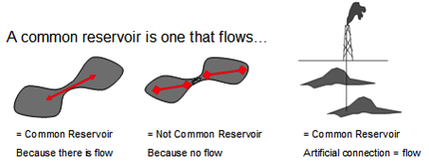

- Size Limits For Compulsory Pooling
  - Gas: 640 acres + 10% tolerance These aren’t big enough for a full field.
  - Oil: 160 acres + 10% tolerance Must voluntarily pool for a bigger field

- Compulsory Pooling > Voluntary Pooling
  - A pooling unit will terminate if superseded by another validly formed unit Hladik v. Lee, 584
  - Thus, a statutory pooling agreement that covers an area formerly covered by a voluntary unit will trump the old unit

- Area of Mutual Interest Agreement (AMI) !!!
  - Often you have a K area that is described in a JOA. Sometimes an AMI will attach that covers the whole area
  - Requirements: Must satisfy §oF
    - Often attached exhibit that has lines drawn in isn’t clear where the boundaries are
  - Look for: AREA OF MUTUAL INTEREST AGREEMENT // The parties to this Agreement ("Parties") own various oil, gas and leasehold interests ("the Leases") on lands located in __ Counties, TX. To facilitate the coordinated acquisition of additional Leases and exploration for and development of oil, gas and other minerals from lands located in the general area of the Parties' Leases, the Parties desire to enter into this Agreement to create an Area of Mutual Interest ("AMI"). In consideration of the mutual benefits… the Parties agree:
      - 1. AMI shall encompass ___ and ___ in ____ County, TX.
      - 2. …any Party acquiring Leases either wholly or partly w/in the above referenced Porciones shall offer in writing an assignment of an undivided 50% interest to the Other Party w/in 60 days of acquisition. Said written offer shall include a legal description and a list of costs. The Other Party shall have 30 days to elect in writing to pay 50% of the costs of acquisition, which shall include but not be limited to bonus, landman fees, phone, fax, and a fixed fee of $25 per acre for overhead. If the Other Party fails to elect to receive an assignment of 50% within 30 days, then it shall be deemed an election not to participate…
      - 3. If either Party, including subsidiaries, assigns or affiliates, amend, extend, or renew an oil, gas and other mineral lease that has been committed to this Agreement and that is within the geographic area of the AMI, then OGL shall be owned by the 1st Party and the 2nd Party in the same proportions as the OGL was formerly owned. The parties agree to pay their proportionate costs to amend, extend, or renew the OGL.
      - 4. This Agreement shall continue for…5 years
      - 5. Addresses for Notice, merger clause, binding on assignees clause, etc

Effect of Pooling
- How get your land released from the unit when you’re in a voluntary pooling agreement You can’t get out of it
  - Requirements: Everyone w/ an interest in the minerals must consent
  - Reason: They have an interest in your minerals (via the agreement) & won't want to release it if your land has the well on it
- Use it or lose it: If you refuse to pool & oil is later found on your neighbors land → You don’t benefit
- RAP: Doesn’t apply to pooling agreements b/c they’re cross-conveyances of royalty interest, which is personal property
- Term-Mineral Interest
  - Pooling can hold a lease while there’s no production on your land
  - Pooling can’t hold a term mineral interest deed bc the pooling is under the lease & not the deed
    - Unless the term mineral interest holder & remainderman agree to let the pooled unit production hold the mineral deed

Field-wide Utilization
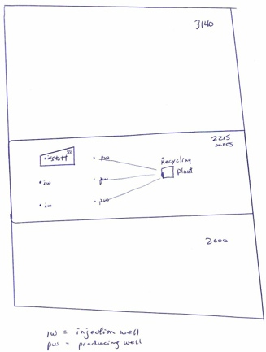
P616 Tildewater Oil v. Stott

- Requirements: Usually must get all lessees, operators, and royalty O’s to agree Tide Water v. Stott, 616

Special Problems

Ownership of Streambeds/Navigable Streams
- Rule: State owns minerals under a navigable stream. Can’t convey minerals under it (bc state owns )
- Rule: No longer a navigable stream when < 29 feet wide Small Act
- Small Act: Exception navigable streams. If state land patent includes a navigable stream bed & needs the acreage to constitute the acreage the state said it granted, then you have title to it if you get a deed from TX General Land Board.

Strips and Gores
- If it’s an easement & the property gets divided & then conveyed → You get the minerals to the right of way. Glover v. Union Pacific
- If abandoned → You get ½ the surface
- Applies: When you border an easement
- Applies to: Inconsequential pieces of land that should be included in a conveyance but not written in it.
- Presumption: Ct presumes they’re part of the conveyance if not worth anything at the time of conveyance
- Strips and Gores Doctrine
- If deed conveys land to the center of a right of way even if it says it only abuts the right of way. If a deed surrounds a right of way it still only conveys to the center, just from both sides.
- If you convey your land but forget to include the property line to the middle of the road → Your conveyed it. Didn’t accidently reserve a little strip of land for pooling royalty
- When is land a strip
  - Smaller than land conveyed
  - Adjacent or surrounded by land conveyed
  - Belongs to grantor at time of conveyance
  - Insignificant value at time of conveyance

Accretion/ Reliction
- Accretion: A river serves as a property boundary, which can move when the river moves Ely v. Briley
  - Look to the legal description
  - If you can’t tell where the old boundary was: The boundary stays w/ the river
- Reliction: Brainard v. State

- Relinquishment Act (It’s constitutional) Tex Nat. Res. Code § 52.189
  - Constitutional
  - History: TX unusual bc state owned the land, an influence from Spanish law. TX started relinquishing minerals to surface O’s. Then TX stopped doing that when they passed the act.
  - Effect: Makes the surface O the agent of the state. He can lease the land temporarily but has no interest in it. He can’t sell his interest permanently, can only sell temporary interest under a current OGL
  - State land that includes oil gas & other minerals → Doesn’t include coal
  - State compensation to Surface O
    - 50% of lease revenues from OGL (includes bonuses, royalties & rentals)
    - 40% of lease revenues from all other minerals (includes bonuses, royalties & rentals)
  - Authorities and Duties of Surface O Agent
    - No Self-Dealing: Can’t lease to himself or a shareholder if his corp subsidiary unless express permission & affidavit limiting benefit. Lying voids it.
    - Fiduciary Duty: Good faith (to state). Must disclose all facts in the state’s interest. Must subordinate his interest to the state when they conflict. Holds CL duties as holder of executive right.
    - If he breaches his duties
      - State can forfeit his rights as the state’s agent & appoint someone else or
      - Automatic 10% penalty on any $ due to the state. Punitive DAS allowed
    - Surface Minerals: Irrelevant where minerals are when they‘re on land subject to the act
    - EX: Lying in an open field → Still the state’s

- Holdouts & gas cycling
  - Can cycle gas to strip it of valuable minerals & then re-inject it back into the reservoir until there’s a market. When you pool, you share the proceeds from these valuable stripped minerals.
  - If a holdout refused to pool his section of a gas reservoir, & cycling is going on → Holdout doesn’t get any proceeds from cycled gas & forfeits the valuable minerals

Bar Exam Illustrations

Question 9 In 1994…
- Who owns the surface of Lot 5? Sue owns it by adverse possession. She’s occupied it, she knows it the salesperson knows it, she’s paid taxes on it. It’s open, continuous, exclusive, adverse to Ron’s prior interest, & Notorious bc both she and the salesperson know that she’s there

- Who owns the Lot 5 mineral estate? No drilling so no OG lessee that has it. Ben and Sues own it. Ben bc it was severed & he recorded the deed. Sue bc she owns by adverse possession

Question… Alex owned
- Is OilCo entitled to construct the proposed pipeline or either the easement or the north tract? No, it’s excess usage of the easement. OilCo has the right to build pipelines but it doesn’t extend to the easement for vehicular ingress and egress.

- If OilCo doesn’t drill a well on the land leased from Carols, what obligations, if any, does it have to Carlos arising from the production on Alex’s land? Duty to protect. They have to drill a well or release, which is part of the implied covenant to protect or Something about pooling…

- These are from Rule 88..In 1955, Able Inc…
  - Can the RRC properly require Able, Rex, or New Oil to plug the abandoned well? Can’t require new operator to do it. Can’t require landowner to do it. Must be done by the RRC. They don’t have to spend the money to plug it
  - What are New Oils responsibilities to Rex once Rex refused to sign the division order? You’re entitled to…under the statute if you give them a statement that complies with those terms. If…then you are not entitled to, and if you do so…entitled to interest
  - To whom should New Oil make the royalty payments for the well on Gloria’s 80-acre tract? Draw picture: 80 acres belongs to new well, 120 acres belongs to the old well… He signed an OGL first. Non apportionment doctrine. He leased, then sold.. Gloria gets it all because she’s the tract owner. This is the non-apportionment doctrine. Under the non-appp…first, the tract is owned by one person. The tract is leased by that person. The tract the segregates it according to meets and bounds. Able did not reserve anything. He conveyed everything, surface and minerals without retaining anything. The wells on Gloria’s land so she gets it all.

Question….
- Is Big Oils lease of Blackacre terminated? Assume he owns the minerals. They’ll claim that if he made the payment before xx/xx/xxxx that it would still be in effect. He didn’t make it. There is no force majeure clause. Arguably fm doesn’t apply here. Lease expires. They don’t refer to a shut in provision, but “a very small amount of gas…” The well must be capable of producing in paying quantities before you can pay shut in. It’s not here. // TCOP. Production was interrupted. That would normally cause a termination under the habendum clause. But the Temporary Cessation of Production Clause (TCOP) may keep it in effect if they made a diligent & good faith effort to restore production

Practice Problems
- A & B are neighbors. If B’s OG flow to A’s property, can B sue A? No, under the Rule of Capture. A is not liable to B for OG that he captures which has flowed from B’s property. Upon capture, the OG becomes A’s personal property.

Bar question, Greg owned…
What is the standard…Clifton v. Koontz analysis. Paying quantities. The test is do the proceeds of production exceed the cost of operations. The 2nd prong is whether a RPO would..what don’t you include? The cost of drilling, equipping, & completing the well.
Can you pay shut in gas royalties on this well? No b/c before you can pay them it must have production in paying quantities. Thus, if doesn’t satisfy Clifton, then you can’t have shut in gas royalties.
What should Jumbo Oil do to preserve its rights under the lease? Explain fully. It could pay delay rentals, so long as they are paid to the right person, at the right time, the right amount, at the right place

Green/Blue Practice Problem

Problem like this on Exam !!! | Answer (refer to our OGL from class)
How do you calculate the unit acres? | Unit Area = total of all tracts. Here, 160 + 80 + 80= 320 Unit Acres
How do you calculate the unit participation factor? | It is the percentage of the pooled unit that each tract has  160/320 = ½  80/320 = ¼  80/324 = ¼  __________  It must total 1 !!!
What | Robert? 1/2x1/5 x 8/8 = 1/10 [think of it like ½ x 1/5 x 1/1]  Tom? ¼ x ¼ x ¾ x 8/8 =

Test tips
- Professor Michael Jones: Jones Gill, LLP, 713-652-4068, mjones@jonesgill.com
- Exam
  - 110 MC (some w/ choice A-I) + 1 Short Essay + 1 Long Essay
  - Will have a MC section on acronyms: http://en.wikipedia.org/wiki/List_of_acronyms_in_oil_and_gas_exploration_and_production
  - Fact situation followed by 5-10 questions. T/F mixed in. Curved. A/B/C’s likely
  - Long essay is on a Division Order Title Opinion
  - Not on Exam: Allowables
  - On Exam: Delay rentals, Open Mines
Other Notes
  - Remember this rhyme: 30 days hath September, April, June & November. All the rest have 31 except February, Which hath 28 days clear, & 29 in each leap year. !!!
  - A working W is better than an oil well- they don’t decline, they only improve
  - 30 days past September, April, June, and November → rhyme for how many days are in each month
  - “Of” in math means multiply ½ of 100 (.025 x 100)
  - Paragraph 1 of OGL should contain a description that meets the §oF
  - RRC doesn’t have jsd over: K’s, trespass conflicts

What is keeping the lease in force?
    - If lease is is PT
      - Was the lease held by payment of delay rentals?
      - Was the lease held by the commencement of operations for drilling (by end of PT)?
    - If lease is in Secondary Term
      - Is there production & what does production mean?
        - Is OG being produced? Sales/Severence/in paying quantities
          - 2 Prong Test (must meet both)
          - Yes --> Lease still in effect
          - No --> Lease not in effect
      - What are the “savings clauses” & has one of them been satisfied to operate as substitutes for production?
        - Operations Clauses (cessation of production, operations, dry hole)
        - Force majeure clause
        - Shut-in Royalty clause

- earlier in class he mentioned a § about who’s responsible for plugging wells -→ was on bar, remember
- In Manziel, the SupCt recognized that: a 'negative rule of capture' appears to be developing. Just as under the ROC a landowner may capture such oil or gas as will migrate from adjoining premises to a well bottomed on his own land, he may also inject into a formation substances which may migrate through the structure to the land of others, even if it thus results in the displacement under such land of more valuable with less valuable substances.

- Browning Oil v. Luecke, 38 concerned horizontal wells and breach of the contractual pooling provision in the oil and gas lease. Since Luecke was not pooled & the horizontal bore holes crossed the Luecke leases and there was production along the bore holes, Luecke argued the ROC applied & that full royalty or double royalty was due as if the Luecke leases were non-pooled drill site tracts
  - The Austin CtApp noted that the ROC, which is premised on drainage from a vertical well, didn’t support Luecke’s claim to royalties on all production from a horizontal well, precisely because:
    - 1) Geophysical characteristics of the formation actually inhibited the natural drainage underlying the ROC
    - 2) production from multiple drill site tracts was involved &
    - 3) the fractures contributing to production were not all adjacent to any single drillsite. The ability of a horizontal well to drain an elongated area depends upon the number of fractures encountered and the length of the drainhole.
    - Rule: ROC doesn’t apply to horizontal bore holes in Texas.
- Standing: π has standing if he suffered an injury caused by the ∆ & is likely to be remedied by the requested relief .
- A royalty interest is an interest in real property that is a distinct part of the mineral estate. Altman v. Blake
- However, the royalty interest is not a possessory interest. Since trespass is an affront to the possessory interest in real property, how can a royalty O have standing to sue for trespass?
- Although royalty is payable only as minerals are produced, a royalty O is entitled to compensation for damage to a reservoir
- underlying an OGL See Elliff v. Texon Drilling and HECI v. Neel

